


AN ISO 9001 : 2008
Certified Organization

SPOTER Distributor Training Manual Vol. Version 1.1

SPOTER VEHICLE TRACKING SYSTEM combines the use of automatic vehicle location in individual vehicles with software that collects these fleet data for a comprehensive picture of vehicle locations. Our vehicle tracking systems commonly using Advance GPS Technology Design at USA. Vehicle information can be viewed on electronic maps via the Internet or specialized software. The data also automatically stored at our server, which can be viewable letter.

01

Product Details:

Spoter is an advanced Vehicle Monitoring System with advanced management capabilities that offers much more features than a standard GPS Tracking system at comparable, or in most cases lower cost. The system is backed by technicians and engineers with the ability to customize expand and successfully deploy it to virtually any application.

Our System, tracks current location and speed by 24 Satellites which assures the owner of best and quality services as compared to other similar looking products in Market.

The solutions we offer provide visibility of your vehicle anywhere in India we also have significant technical advantages over other competing products in the market today. These solutions allow you to:

• Increase safety of vehicles and occupants
• Reduce operating cost
• Have control of your vehicles
• Reduce risk of theft to the barest minimum.
• Increase productivity.

Satellite Based Vehicle Tracking System

A Satellite based Vehicle and Fleet Management System and Solution.

Spoter is a comprehensive device, which helps a owner to Track, Monitor, Safe-guard, Control and Manage a vehicle, driver, Goods and Fleet through a single web interface.

Due to its low-cost and effective management, it make easy to process and monitor operations for fleet owners like logistic, Transport, Education, Rental Service operators, corporate companies, Hospitals, Security Services, Government and many other types of Organizations and Agencies.

The essence of telemetry and use of location based services (LBS) is to enhance security, efficiency and reduce operation cost. In addition, it also enhances effective monitoring and control of personnel and assets.



02

Product Features:
The features included in our Basic model for customers are as follows:

1) High sensitivity GPS chip-set.

2) Built–in switching power supply, wide voltage input: 9V to 24V.

3) Optional SMS functionality supported.

4) Built-in monitoring CPU, automatic fault recovery.

5) Support GSM 900/1800MHz cellular network as data carrier.

6) Built-in GSM and GSM Antenna.

7) Built-in Storage Capacity.

8) Optional Wire-tapping (Voice monitoring) - Optional.

9) Inbuilt motion sensor for power saving and exact location identification.

10) Geo- fencing control.

11) Over speeding alarm.

12) Portable, easy to install.

13) Real Time System View (Track a wide range of vehicles at a time).

14) On board data storage (The tracking information of 30 days of vehicle stored automatically.)

15) Advanced Reverse Geo-coding based on accurate google map data (accurate street names for stops)

16) Flexible Reporting Platform (Time on customer site, over idle, service / odo-meter, stop with distance travelled, geofence reports, etc.)

17) Mobile interface (View vehicle locations from a mobile device)

18) Anti-theft protection.

19) One year Standard warrantee.

20) Multiple Server support.

BENEFITS

• Internet Tracking: we offer real-time tracking, i.e. you have complete control of your vehicles by monitoring its activities on-line.

• With the enable/disable facilities, Theft and Misuse of automobiles and other assets will be
reduced.

• With its effective work distribution and monitoring, staff productivity will be enhanced.

• Reduce cost with fuel sensor to monitor fuel loading and usage.

• Safe-guards vehicles by monitoring maintenance, as well as on time information during accident or theft.

• Customized reports for various departments e.g. Admin/Finance etc.

• Accident dispute can be managed better by monitoring speed and driving habit of the driver.

• Speed: it has a perfect fast speed in operation between user and vehicle.

• Uses SMS and Internet for presenting reports.

• SMS alert (Optional) : receive additional SMS for specified events on your vehicle.

03

Others Information:

Limitations
Spoter shall be limited to the repair or replacement of any parts of the product, which are defective in materials. Spoter Shall not be liable in any way for Product failure, or any resulting loss or damage which arises from:
• Use of product in an application for which it was not designed or intended.
• Corrosion, degradation or wear and tear.
• Failure to service or maintain the product in accordance with Spoter recommendations.
• Failure to Data & Satellites Network.
• Faulty or deficient installation of the product.
• Any modification of alteration of the product.
• Conditions that exceed the products performance specifications or safe working loads.
• This warranty does not cover any incidental costs incurred for the investigation, removal, carriage, transport or installation of product.
• Service by anyone other than authorized Spoter representatives shall be taken as warranty void unless it accords with Spoter guidelines and standards of workmanship.

Liability
Spoter shall not be responsible for
• Any loss of anticipated turnover or profit or indirect, consequential or economic loss, Damages, costs or expenses payable to any third party, Death or personal injury, Any loss of warranty of vehicle due to installation of device.

Procedure
• Both warranty and non-warranty repairs can only be performed at Spoter. The customer shall send the goods together with an order for warranty or non-warranty repair to the Spoter service office. The order shall be delivered in writing by mail or electronic mail. The order must contain a detailed description of the defect. Both warranty and Non-warranty repairs shall be carried out by Spoter in25-30 working days from the receipt of order.

• In case of warranty repair, the customer shall be responsible for transport of goods to service office and
transport of goods back to the customer. If it is found that the repair is not subject to warranty, all costs of
repairs will be borne by the customer.

Terms & Conditions:

Warranty
1 year repair/replacement standard limited warranty on the Tracking Device.

Annual Maintenance Cost Rs. 2000/-
To extend the comprehensive warranty you will need to cover them under an AMC.
AMC will cover:
• Unit replacement in case of damage one time maximum for four times.
• 4 preventive service calls per unit yearly
• 4 trouble-shooting calls per unit yearly

Terms and Liabilities
A. Payment: 100% advance against purchase order.

B. Delivery: Delivery within 2-3 Weeks of receipt of purchase order and advance payment.

Carry – In Warranty
Spoter warrants that in normal usage and with proper maintenance, its product (Vehicle Tracking Unit) will conform to their specification for a period of 12 months from the date of purchase by the customer, subject to the conditions,

Any product, which proves to be defective in normal usage during that 12 months period, will be repaired at Spoter or replace by Spoter. Warranty does not cover any battery, pad, Antennas & cables.

04

Service Level Details:

The features included in our Basic model for customers are as follows:

1) High sensitivity GPS chip-set.

2) Built–in switching power supply, wide voltage input: 9V to 24V.

3) Optional SMS functionality supported.

4) Built-in monitoring CPU, automatic fault recovery.

5) Support GSM 900/1800MHz cellular network as data carrier.

6) Built-in GSM and GSM Antenna.

7) Built-in Storage Capacity.

8) Optional Wire-tapping (Voice monitoring) - Optional.

9) Inbuilt motion sensor for power saving and exact location identification.

10) Geo- fencing control.

11) Over speeding alarm.

12) Portable, easy to install.

13) Real Time System View (Track a wide range of vehicles at a time).

14) On board data storage (The tracking information of 30 days of vehicle stored automatically.)

15) Advanced Reverse Geo-coding based on accurate google map data (accurate street names for stops)

16) Flexible Reporting Platform (Time on customer site, over idle, service / odo-meter, stop with distance travelled, geofence reports, etc.)

17) Mobile interface (View vehicle locations from a mobile device)

18) Anti-theft protection.

19) One year Standard warrantee.

20) Multiple Server support.

• In case of any manufacturing defect in the Tracking Unit or need for any trouble-shooting in the Tracking software, the support team will respond to addressed problem within 6 hours provided the vehicle is made available for check at mutually agreed location.

• For the location other than mutually agreed location, the service engineer will assess the cause of problem and will provide the time and assistance to repair, on case basis. The response of support service will be in addition to the travel time to provide the response.

DEMO :

For demo: login onto: www.spoter.in Under ‘Tracking Server 1’.

USERNAME: demo
PASSWORD: demo

You can take a look of our demo videos at:
https://www.youtube.com/watch?v=Vlg1aFN2AuY

05
SPOTER
At-A-Glance:

GPS Vehicle tracking system is nothing but a global positioning system of vehicle tracking system with an installation of an electronic device. The device sends signals time to time by using INTERNET/GPRS. So Customer needs a GPRS enabled SIM with all the devices. It requires data usage of approximately 50MB/month. Additional Monthly Server charges are required for live tracking.

This is a satellite controlled mobile type device which will be installed with your vehicle; this device
collects all the location, speed data from satellites. After getting the data, the device sends the data to
our server via gprs connection of a SIM and customer track his vehicle from our web panel.

Key Features:
- View real-time location,
- Fuel Sensor,
- Track mileage,
- Establish routes and rules to alerts,
- Vehicle operating status,
- View the vehicles from anywhere anytime through Internet connected Mobile / Pc.

For more details please
contact us at : +91 7872766958
or write us at: sankar@SPOTER.in

Thanking You,
Team Spoter.

Warm Greetings,

Welcome to SPOTER VEHICLE TRACKING (India’s No.1 rapidly growing vehicle tracking System). SPOTER offers web based GPS/ GPRS/ SMS Tracking Device and web based user control application, enabling full vision and Track record of his/her Vehicle. Our quick and better services, large collection of various GPS products, maximum features and above all transparency have made SPOTER more efficient in the sector of Vehicle Tracking, Safety and Security of our Family and Customers.

Actually this is a tracking system by which you can track your vehicle location, speed, Fuel Consumption, Trip statements and Records etc instantly with your mobile or pc, not only that the tracking data will be stored in our server for 30 days, through which you can find your vehicles data over a period of time.

SPOTER is a subsidiary company of WEBINOVATION, operating since 2004, and ‘Spoter’ was launched in 2014. For more information about our products, you can visit our SPOTER website www.SPOTER.in.
Select ‘SERVER 1’ and enter Username: demo, Password: demo. You can feel the experience of Spoter Vehicle Tracking System Live…



06

Company Details:

Few more areas which WebInovation covers are :

• Web hosting & Development.

• Software and Web development

• Custom database software systems

• ITES

• Organization Automation & Consultation

• E-Commerce development

• Brand development .

• Communication Services.

• Voip Services

• Project Management & Maintenance

• CCTV Security Surveillance System

• Digital Signature resourcing.

Company Information :

SPOTER is a part of WebInovation which is a leading Information Management Solutions provider in India since 2004. We are associated with investment planning, developing distribution network, leadership and after all assured returns of investment, we have worked with some leading brands dealing with FMGC , Information Technology, life Style, Home Appliance, Media & Entertainments and some heavy industries like Cement, Steel, Paints etc.

WebInovation associates with the expanding world of Information Technology, developed great expertise as a leading Outsourcing Service provider to MNCs by giving onsite support to their clients.

WebInovation established itself as an eminent System and Network Integration service provider
Encompassing a varied range of Information Management Services. We are team of IT professionals having more than 9+ years of development experience and having excellence in delivering high quality, cost effective and reliable IT services (ITSSM) to customers.

Webinovation, headquarters in Haldia, West Bengal, India. With wide network of branches throughout India.

07

SPOTER Business Opportunity :

Any business opportunity generated or approaching us from any retailer area or nearby areas (where retailers are not yet appointed), shall be redirected to the relevant retailer for Welcoming and converting into business.

The Distributor will be responsible to coordinate with retailers for their complete Activation in distributor area.

Once any lead is ready for business conversion sales team will pass the prospect to the distributor to discuss financials, terms and close the deal.

We offer assured and consistent profit margin upto 50% to our distributors along with a recurring profit from each client every year.

Franchise Advantages:
- Operating manuals
- Field assistance
- Head office experts will assist in setting up franchise
- Lucrative returns on investment

Which make this opportunity unique one.

Grabbing this business opportunity is the best step you can take to become a leading entrepreneur of tomorrow!

Warm Greetings from SPOTER!!!

Thanks for showing interest for the Business opportunity of Spoter –Vehicle Tracking and Fleet Management Solutions.

Spoter is a unique Vehicle Tracking and Fleet Management System which profits an individual or a business by providing current and Past Travel data of their assests/vehicles.

Key benefits of Spoter include: Real-time vehicle location, vehicle status, route and driving details, fuel consumption, important alerts, geo-fencing, detailed reports etc.

Spoter is mainly promoted in corporate sector and Fleet owners like logistic, transport, education, rental service operators, corporate companies, hospitals, security services, government and many other types of organizations and agencies in coordination with a distributor.

The role of a distributor mainly involves coordinating with the Sales Team and promotes the products of Spoter by various marketing, promotional and sales activities at distributor areas.

08

PRICING STRUCTURE:

EMPLOYEE TRACKING SYSTEM

Distributor Price Rs. 1800/- per Employee Per Year.

VEHICLE TRACKING SYSTEM

As per new pricing structure (mentioned Below) we have made ‘Streaming Server & Setup’ yearly charges as Optional.

‘Streaming Server & Setup’ option can be opted by a customer anytime as per his / their need and suitability.

FOR BETTER MARKET PENETRATIONS AND BUSINESS GROWTH.

We have made few changes and modifications in our existing services and pricing for better market penetrations and growth of your business successfully and also to be ahead always in this competitive market race.
With the new structure we wish not just to increase sales but also we will be able to deliver services in a better way to achieve customer satisfactions and expectations.

NEW DISTRUBUTOR PRICING For Vehicle Tracking System . . Product Description Charges (Per Unit) Remarks .
DEVICE – M2100 | 3,800/- | One TimeNG
Server Subscription | 1,800/- | Yearly / Mandate
Data Subscription | 1,400/- | Yearly / Mandate
Streaming Server | 3,000/- | Yearly / Optional



09
SPOTER Employee Tracking System

We have three System Models for customers. Here give features information about our standard basic System model.

1. High sensitivity Android Programme.
2. Built –in switching service start-up.
3. Optional SMS functionality supported.
4. Built in monitoring & automatic fault recovery.
5. Support GSM 900/1800MHz cellular network as data carrier.
6. Support Any type of Android OS Version.
7. Inbuilt motion sensor for power saving.
8. Geo- fencing control.
9. Portable, easy to install.
9. Real Time System View (Track a multiple Employee at a time).
10. On board data storage (The tracking information of previous month of your employee movement stored automatically.)
11. Advanced Reverse Geo-coding based on accurate google map data (accurate street names for stops)
12. Flexible Reporting Platform (Time on customer site, over idle, service/odometer, stop with distance travelled, geofence reports, etc.)
Mobile interface (View vehicle locations from a mobile device).

The solutions we offer provide visibility of your vehicle anywhere in India we also have significant technical advantages over other competing products in the market today. These solutions allow you to:

- Improve workforce productivity.
- Reduce operating cost.
- Have control of your employee movement.
- leads to the increment in performance.



Spoter [Android Mobile based tracking System] is a comprehensive, Employee monitoring, control and management. It’s an effective low cost operation for fleet and HR operators, corporate organizations and agencies, Government. The essence of telemetry and use of location based services (LBS) is to enhance security, efficiency and reduce operation cost.

In addition, it also enhances effective monitoring and control of personnel. We, Spoter is an advanced Monitoring System with management capabilities that offers much more features than a standard GPS Tracking system at comparable, or in most cases lower cost. The system is backed by technicians and engineers with the ability to customize expand and successfully deploy it to virtually any application.

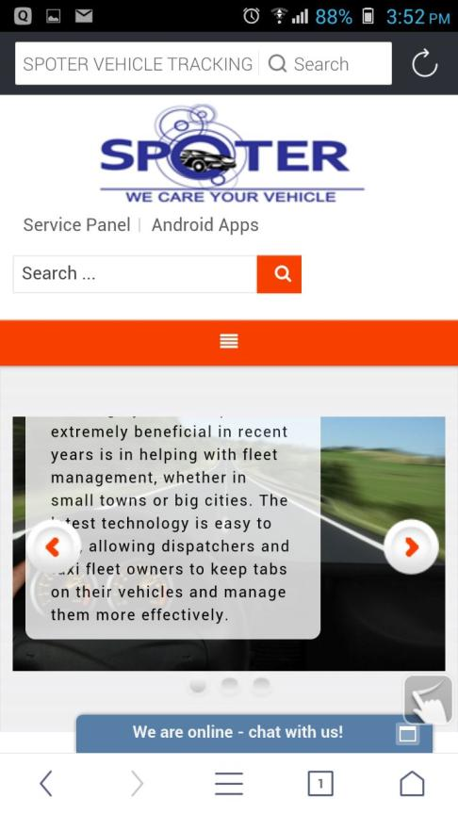

10
Track in
MOBILE

Go to our website www.spoter.in
AND DOWNOAD THE APPS

- CLICK HERE
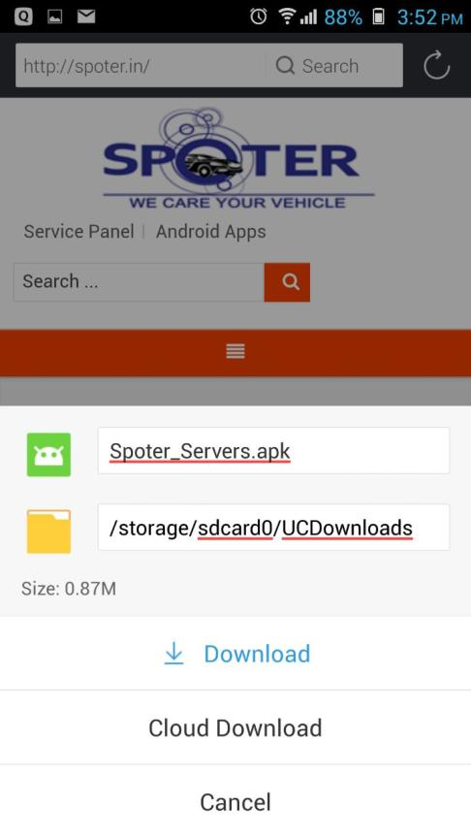
DOWNOAD THE APPS

- CLICK HERE

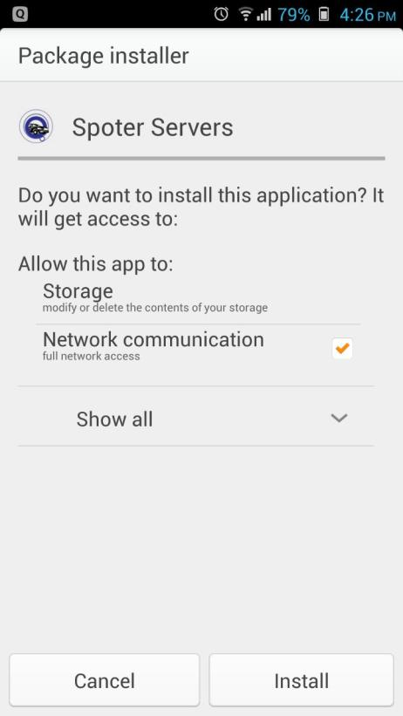
- CLICK HERE
INSTALL THE APPS

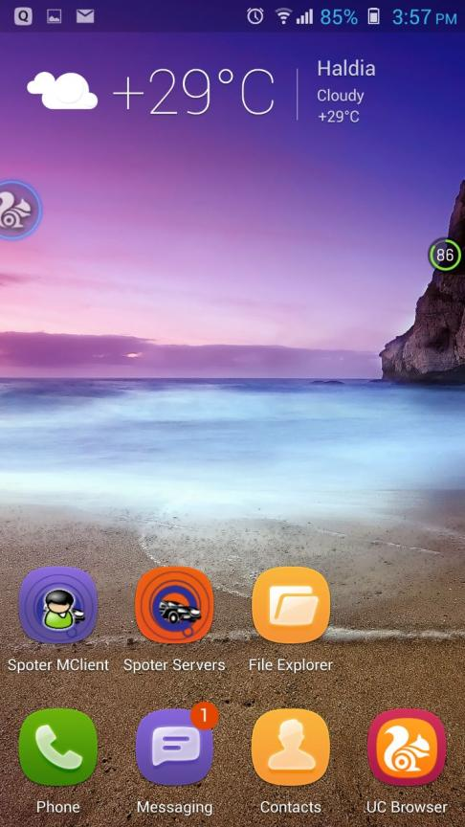
- CLICK HERE

Go to Your Menu and Open
SPOTER SERVERS ICON.

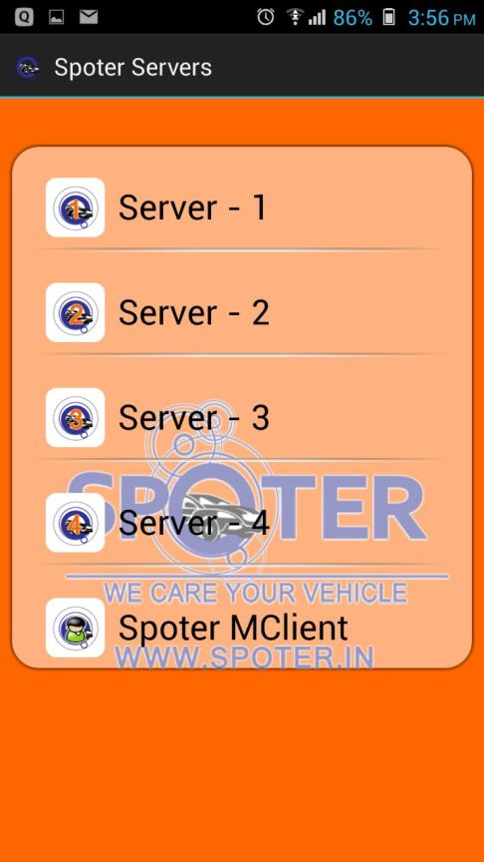
- CLICK HERE

CLICK ON : SPOTER SERVER-1

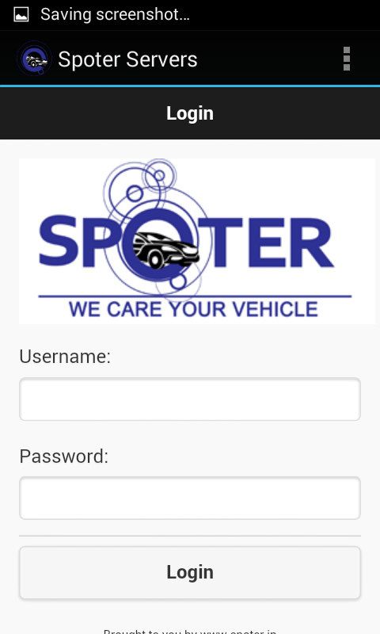
Type USERNAME and PASSWORD
[Provided by SPOTER]
Go to your login

- TYPE HERE

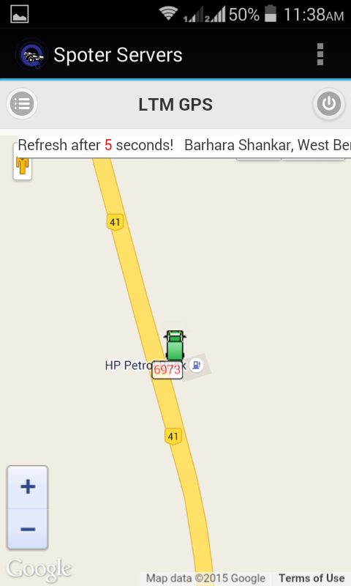
Zoom IN /Out Map

LOCATION ON MAP

LIVE LOCATION

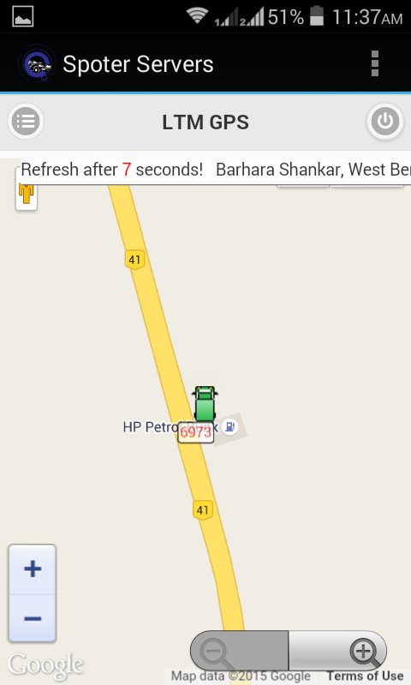
- CLICK HERE
Click the ICON for Select your Vehicle

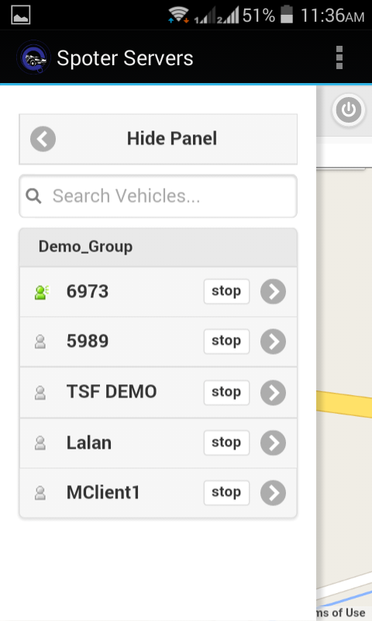
CLICK to select your Vehicle

- CLICK HERE
CLICK DONE
For Log OUT

- CLICK HERE
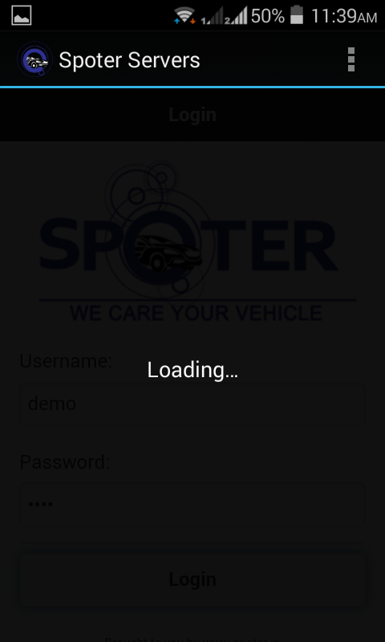
LOGING OUT
FROM SERVER

- CLICK HERE

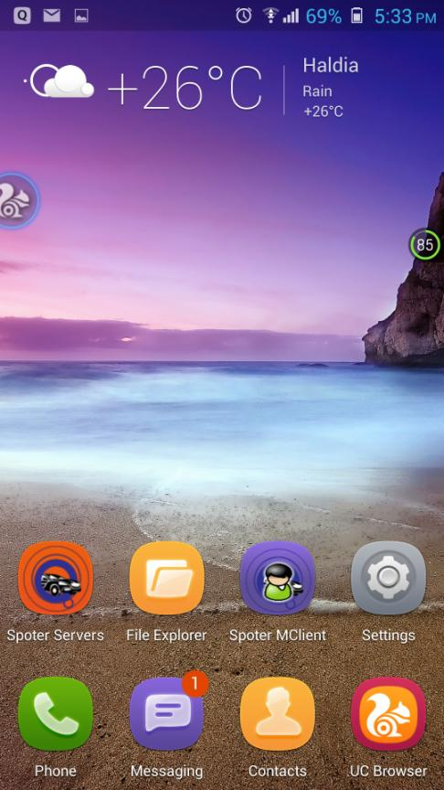
THANK YOU

11

Vehicle tracking system Installation:
1. Introduction

GPS stands for Global Positioning System. High above us, there are a group of 27 satellites orbiting the earth constantly providing information to tell us the map location (latitude and longitude) of a car or other vehicle. It also tells us how fast the vehicle is traveling and in what direction.

GPS Tracking (Global Positioning System) has been around since 1973 and it works via a network of satellites in orbit that determines the location and time of a device.

Nowadays, it isn’t a niche technology – most, if not all of us, have mobile phones and tablets with integrated GPS tracking systems.

In fact, since 2005 the Federal Communications Commission (FCC) has required mobile phones to have GPS tracking capabilities for emergency purposes.

Contents:

1. Introduction
2. Basics
3. Benefits
4. Spoter
- Specification
- My Device
- LED Indications
- ▪ Installation
- ▪ Placement
- ▪ Wiring
- ▪ Powering on/ off
- ▪ Side key function
- ▪ Troubleshooting
- ▪ SMS command
5. FAQ’s

Tracking Devices :

One of the easiest applications to consider is the simple GPS tracking device; which combines the possibility to locate itself with associated communications technologies such as radio transmission and telephony.

Tracking is useful because it enables a central tracking centre to monitor the position of several vehicles or people, in real time, without them needing to relay that information explicitly. This can include children, criminals, police and emergency vehicles, military applications, and many others.

The tracing devices themselves come in different flavors. They will always contain a GPS
receiver, and GPS software, along with some way of transmitting the resulting coordinates. GPS watches, for example, tend to use radio waves to transmit their location to a tracking center, while GPS phones use existing mobile phone technology. The tracking centre can then use that information for co-ordination or alert services. One application in the field is to allow anxious parents to locate their children by calling the tracking station - mainly for their peace of mind.

GPS vehicle tracking is also used to locate stolen cars, or provide services to the driver such as locating the nearest petrol station. Police can also benefit from using GPS tracing devices to ensure that parolees do not violate curfew, and to locate them if they do.

Basics :

The actual principle of GPS is very easy to appreciate, since it is exactly the same as traditional “triangulation” (although this is not quite correct, as GPS does not use angles). If one imagines an orienteer needing to locate themselves on a map, they first need to be able to find at least three points that they recognize in the real world, which allows them to pinpoint their location on the map.

They can then measure, using a compass, the azimuth that would be needed to take them from the point on the map to their current position. A line is then drawn from each of the three points, and where the three lines meet is where they are on the map.

Translating this into the GPS world, we can replace the known points with satellites, and the azimuth with time taken for a signal to travel from each of the known points to the GPS receiver.

This enables the system to work out roughly where it is located - it is where the circles
representing the distance from the satellite, calculated on the basis of the travel time of the signal, intersect.

Of course, this requires that the GPS locator has the same coordinated time as the satellites, which have atomic clocks on board. To do this, it cross checks the intersection of the three circles with a fourth circle, which it acquires from another satellite.

These last two require maps and mapping software which differ vastly from traditional GPS
solutions, and as such can often be augmented with other packages designed to allow the user to import paper maps or charts.

There are even GPS solutions for use on the golf course. Golf GPS systems help the player to calculate the distance from the tee to the pin, or to know exactly where they are with relation to features such as hidden bunkers, water hazards or greens. Again, specific maps are needed for such applications.

If the four circles no longer intersect at the same point, then the GPS system knows that there is an error in it’s clock, and can adjust it by finding one common value (one second, half a second and so on) that can be applied to the three initial signals which would cause the circles to intersect in the same place.

Behind the scenes, there are also many complex calculations taking place which enable the system to compensate for atmospheric distortion of the signals, and so forth, but the principle remains the same.

Navigation Systems :

Once we know our location, we can, of course, find out where we are on a map, and GPS mapping and navigation is perhaps the most well-known of all the applications of GPS. Using the GPS coordinates, appropriate software can perform all manner of tasks, from locating the unit, to finding a route from A to B, or dynamically selecting the best route in real time. These systems need to work with map data, which does not form part of the GPS system, but is one of the associated technologies that we spoke of in the introduction to this article. The availability of high powered computers in small, portable packages has lead to a variety of solutions which combines maps with location information to enable the user to navigate.

One of the first such applications was the car navigation system, which allows drivers to receive navigation instructions without taking their eyes off the road, via voice commands. Then there are handheld GPS units, such as those from Garmin and Magellan and a dozen other manufacturers, which are commonly used by those involved in outdoor pursuits, and only provide limited information such as the location, and possibly store GPS waypoints. A waypoint being a location that is kept in memory so that the unit can retrace the same path at a later time.

More advanced versions include aviation GPS systems, which offer specific features for those flying aircraft, and marine GPS systems which offer information pertaining to marine channels, and tide times, etc.

Vehicle tracking systems are also popular in consumer vehicles as a theft prevention, monitoring and retrieval device. Police can simply follow the signal emitted by the tracking system and locate the stolen vehicle. When used as a security system, a Vehicle Tracking System may serve as either an addition to or replacement for a traditional car alarm. Some vehicle tracking systems make it possible to control vehicle remotely, including block doors or engine in case of emergency.

The existence of vehicle tracking device then can be used to reduce the insurance cost, because the loss-risk of the vehicle drops significantly.

Some vehicle tracking systems integrate several security systems, for example by sending an automatic alert to a phone or email if an alarm is triggered or the vehicle is moved without authorization, or when it leaves or enters a geofence.

Vehicle tracking systems are widely used worldwide. Components come in various shapes and forms but most utilize GPS technology and GSM services. While most will offer real-time tracking, Others record real time data and store it to be read, similar to data loggers. Systems like these track and record and allow reports after certain points have been solved.

Benefits :

Vehicle tracking systems are commonly used by fleet operators for fleet management functions such as fleet tracking, routing, dispatching, on-board information and security. Along with commercial fleet operators, urban transit agencies use the technology for a number of purposes, including monitoring schedule adherence of vehicles in service, triggering changes of vehicle's destination sign displays at the end of the line (or other set location along a bus route), and triggering pre-recorded announcements for passengers.

Such devices are also used to provide customers with real-time information as to the waiting time until arrival of the next bus or tram/streetcar at a given stop, based on the nearest vehicles' actual progress at the time, rather than merely giving information as to the scheduled time of the next arrival. Transit systems providing this kind of information assign a unique number to each stop, and waiting passengers can obtain information by entering the stop number into an automated telephone system or an application on the transit system's website.

Some transit agencies provide a virtual map on their website, with icons depicting the current locations of buses in service on each route, for customers' information, while others provide such information only to dispatchers or other employees.

Other applications include monitoring driving behavior, such as an employer of an employee, or a parent with a teen driver.

8. Optimize financial management – Accurate GPS log data allows you to create more useful profit and loss analyses, improves accountability, and enables better budget preparation.

9. Superior route planning – Smarter route planning and more predictable schedules allow you to stay competitive and reduce costs.

10. Manage maintenance – Create alerts based on time, mileage, or engine hours to develop advanced vehicle maintenance routines.

11. Ease of use – User-friendly interfaces enable easy access to quality information and data from any computer or mobile device.

12. Locate assets – Locate lost or stolen vehicles or other assets with exact location details made possible by GPS technology.

13. Improve safety – Enhance safety and security for personnel by providing direct assistance and support, monitoring vehicle activity, and implementing two-way communication between drivers and dispatchers.

14. Be competitive – Compete with market rivals by implementing unparalleled commercial fleet tracking capabilities. You will be able to provide better service and the money you will save with fleet GPS will help you keep costs low.

Employee Benefits

Higher Customer Retention For service drivers, retaining current customers is a high priority. In several cases, the detailed reports Our GPS Tracking System provided led to higher customer retention numbers. Simply put, customers like to see proof that service was completed on time, and by providing that proof, you keep your customers and your commission.
Benefits of GPS Fleet Tracking :

1. Save on operating expenses – Reduce unnecessary overhead costs by eliminating excess fuel consumption, billing discrepancies, unnecessary overtime expenses, and unauthorized vehicle usage.

2. Reduce insurance costs – Many insurance providers give discounted premiums (up to 35 percent) for companies that have vehicles equipped with a real-time fleet tracking system.

3. Optimize resources – Don’t wait until it’s too late to make a money-saving change. Fleet GPS enables you to monitor daily use of your resources in real time and with useful tools like analytics and reports.

4. Maximize vehicle utilization – Eliminate unnecessary idle time and vehicle misuse to get the most from your fleet.

5. Keep customers happy – Real-time vehicle tracking allows you to offer first-class customer service.

6. Be more predictable – Provide customers with accurate delivery times and benefit from better vehicle and employee utilization at the same time.

7. Maximize labor costs – Increase employee productivity and efficiency by eliminating downtime, preventing dispatch inaccuracies, and reducing tardiness.

Increased Company Profits

Increased savings and company profits translate to better 401(k) results, better maintenance programs to minimize on-the-road problems, replacement of aging equipment, etc.

New Incentives

Because Your New GPS Tracking System allows you to measure performance efficiently, you can create new incentives based solely on productivity. It is amazing to see the changes in performance once drivers take the competitive spirit to heart. Before you know it, they will be helping you find new ways of bringing in revenue.

Increased Driver Safety

Financial gain is not the most important benefit for drivers. The incidence and severity of crashes and driver fatalities increase disproportionately with speed. Because maximum speed is automatically recorded, driver safety can be easily monitored.

Improved Driver Morale

Because with Your New GPS Tracking System driver accountability is not an issue any longer, you do not run the risk of getting caught up in "Gotcha" Management. On the contrary, you now have a tool to catch your drivers doing something good so you can enhance their performance and self-esteem. Good drivers are usually reluctant to report their inefficient counterparts. In many cases, good employees wind up carrying the burden of the "Slackers". This has an adverse impact on morale. You now have the tool to deal with unproductive drivers.

Protection against False Claims

Your New GPS Tracking System provides irrefutable data showing when and where each vehicle has traveled, providing protection against false accident claims and reports of late arrivals at scheduled appointments.

Service Time Tracking

Your New GPS Tracking System provides electronic verification of service time, providing drivers with "Back Up" in case of customer challenges.

Hands-free Mileage Log

Your New GPS Tracking System provides an accurate, hands-free mileage log, saving valuable time.

Vehicle Take Home Policies

Because evening and weekend use can be monitored, some companies are now able to allow employees to use fleet vehicles after-hours. This saves many employees, and the company valuable, time and fuel. Management may opt to charge the employee a small monthly fee for this privilege. It can be optional or mandatory. It can allow your employee to sell one vehicle and save about $300 per month.

SPOTER
Spoter is a comprehensive device, which helps a owner to Track, Monitor, Safe-guard, Control and Manage a vehicle, driver, Goods and Fleet through a single web interface.

Due to its low-cost and effective management, it make easy to process and monitor operations for fleet owners like Logistic, Transport, Education, Rental Service operators, corporate companies, Hospitals, Security Services, Government and many other types of Organizations and Agencies.

The essence of telemetry and use of location based services (LBS) is to enhance security, efficiency and reduce operation cost. In addition, it also enhances effective monitoring and control of personnel and assets.

Spoter is an advanced Vehicle Monitoring System with advanced management capabilities that offers much more features than a standard GPS Tracking system at comparable, or in most cases lower cost. The system is backed by technicians and engineers with the ability to customize expand and successfully deploy it to virtually any application. Our System, tracks current location and speed by 24 Satellites which assures the owner of best and quality services as compared to other similar looking products in Market.
How GPS tracking brings change in daily Life?

• For parents, it takes some of the worry out of your kids driving long distances home from college. You know where they are and when to expect them home.
• For parents of teenagers, you never have to wonder if your son or daughter is where they say they are. No more late night phone calls asking – “Where are you?”
• For baby-boomers, the shoe is on the other foot - it helps to take some of the worry out of your elderly parents driving home from vacation or just driving around town. You know where they are and this allows them to be more independent.
• Imagine how thrilled your customers will be when you can tell them exactly when to expect their delivery!
• For employers, using GPS tracking allows you to know how fast your employees are driving, how long a break they are taking (vehicle hasn’t moved), and if they are where they say they are!
• GPS tracking also allows you to monitor fuel usage based on how fast your employee is driving and the automatic mileage feature reminds you to schedule, regular preventative maintenance.
• GPS tracking is customer service at its finest! You know instantly which of your drivers is closest to the customer needing help. And Imagine how thrilled your customers will be when you can tell them exactly when to expect their delivery!
• GPS Tracking can eliminate the need for having your truckers fill out driving logs.
• Many insurance companies now offer discounts for vehicles protected with tracking systems.

5. Geo Fencing.
Geo-fencing takes alert customization to the next level. User can create geographical boundaries called Geo fences on the map around a landmark. An alert is sent out every time the vehicle enters or exits the Geo fence. This opens up immense possibilities in different ways of using the monitoring information that can translate into increased operational efficiency, workforce optimization and elevated security and safety levels for the user.

6. Historical Reports and Dashboard summary.
For most businesses where medium to large fleet is involved, access to location and event reports provides high ROI. Fleet managers can track and analyze information on their vehicles up to 30 days in the past and make informed decisions that could positively impact their business.

Spoter Tracking Solution comes with enterprise dashboard has a comprehensive set of graphical reports. This gives user an overall view of the metrics that matter for their business performance. There are reports for total distance traveled, idling time, over speeding, stoppages and utilization. user can see the metrics for different groups of vehicles and for different time periods.

7. Easy to use, user friendly interface.
A simple and intuitive user interface provides powerful features like group-wise access without the need for multiple accounts, bird’s eye view of entire fleet and the ability to report historical and real-time data. A simple yet well-developed intuitive user interface allows easy access to the right information to make informed decisions.

8. Access Control and User Management.
For business owners, user management and access control is an important vehicle tracking system feature. User is able to add and modify the user profile, and also manage their access privileges via roles. User should be able to assign one or more pre – defined roles to a user and perform grouping wherein a set of users are placed in a group. With this user can perform vehicle tracking for a group of vehicles and also view the report information for a group as a whole.
Some essentials features of Spoter :

1. Real Time Tracking
Spoter Tracking devices are enabled with real-time monitoring. Location of the vehicles is tracked on the map as it moves from point to point. The GPS location of your vehicle is displayed on a map along with vehicle speed if the vehicle is moving. The current state of the vehicle like moving, parked since or idle is shown using map markers. Multiple vehicles can be grouped and managed simultaneously using simple to use interface.

2. Trip History.
You can track all the trips made by the vehicle graphically on the map. Information such as kilometers traveled, stoppages, idling, engine time and average speed is displayed. Over speeding and overdrive stretches are highlighted on the map. Spoter Tracking Systems also come with an option to replay the entire trip. This feature brings in value for both business owners and chauffeur driven car owners.

3. Alerts.
Using vehicle tracking system features like over speeding alert, start of day alert, route deviation alert and excessive stoppage alert, one can analyze driver behavior and optimize fuel usage and optimizing workforce. Depending on your need there are several alerts that can be configured: Idling Alert, Stoppage Alert, Tampering Alert, Over-speeding Alert etc. For consumers looking for vehicle tracking system for personal use features like maintenance alerts and fuel pilferage alerts prove to be useful.

4. Anytime Anywhere Access.
In today’s connected world where any and every information is available at your fingertips, it is imperative invest in a vehicle tracking system that is accessible on web and on smart phone. This is especially useful when the car tracking device is used by discerning parents to track school bus or chauffeur driven cars carrying children. The easy anytime, anywhere access with user friendly app keeps you abreast with your vehicles movement in real time no matter where you are. .

Specification:

Dimension | 90(L)x45(W)x13.5(H) mm
Weight | 45g
Operation Temperature | -30℃ -70℃
Operation Voltage | 9-36vDC
Humidity | 20% -80%
GSM Frequencies | 850/900/1800/1900 MHz
GPRS | Class 12
GPS Sensitivity | -159dBm
Acquisition Sensitivity | -144dBm
Position Accuracy | 10m
TTFF （Open Sky） | Cold Start: ＜38s
TTFF （Open Sky） | Warm Start: ＜32s
TTFF （Open Sky） | Hot Start: ＜2s
GSM/GPS Antenna Built-in design | LED Indicator GSM-green, GPS-blue, Power-red
Data Transmit | TCP, SMS
GSM/GPS Antenna Built-in design | LED Indicator GSM-green, GPS-blue, Power-red
Non-movement Detection | Movement alarm based on built-in 3D motion sensor
Mileage Report | Track by time/distance interval

9. Analytic.

Some tracking devices have innovative enterprise solution designed to harness the power of location based services and integrating it with cloud computing to make actionable fleet data available at the operator’s fingertips to ensure predictive performance of the fleet.

10. Easy Installation.

Ease of installation and maintenance is an important consideration. One should look for a compact device that can be installed discreetly (under the dashboard). Spoter supports OBD connectors which are a better choice for a ‘plug and play’ solution. Compatibility with different models of the car is also a factor to consider.

The solutions we offer provide visibility of your vehicle anywhere in India we also have
significant technical advantages over other competing products in the market today. These solutions allow you to:

• Increase safety of vehicles and occupants
• Reduce operating cost
• Have control of your vehicles
• Reduce risk of theft to the barest minimum.
• Increase productivity.

LED Indications :

GPS LED Indicator
Flashing (1s on, 1s off)  Continuously bright  Continuously dark | Searching GPS signal  GPS fix  No GPS fix or initializing
GSM LED Indicator
Quick flashing  Continuously bright  Continuously dark |  | GSM initializing  Connected to Server Successful  No GSM signal
POWER LED Indicator
Flashing  Continuously bright  Continuously dark |  |  | Power on  Not working properly  Power off
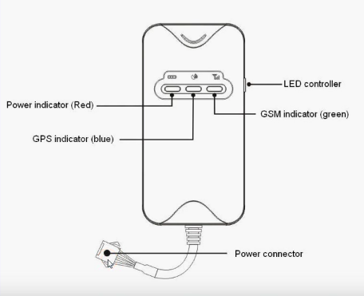
Selecting installation place:

There are two kinds of installation: Covert and Non-covert.
If you need the covert installation, please refer installation to an auto electrical contractor.

Note:
1. To prevent theft of the device, the device should be installed as covertly as possible.

2. Avoid placing the device close to higher power electrical devices, such as reversing radar, anti-theft device or other vehicle communication equipment.

3. The device should be fixed into position with cable ties or wide double-side tape.

4. Your device has built-in GSM antenna and GPS antenna. During installation, please make sure the receiving side face is up, with no metal object above the device to interfere with GPS reception.
Method of installation

Preparation before installation:

1. Open the packing box to check whether the type of device is correct and whether the
accessories are included.

2. This product is a high-tech electronic device, installation should be undertaken by a professional.

3. Please follow the following procedures to install your GT02A. During installation, there
should be no power to the device.

Installing SIM card:
each needs a GSM SIM card.

The SIM card used should be enabled for GPRS.

1. Testing SIM card: to test SIM card, please install it into a normal GSM mobile and ensure it can send and receive SMS, and enables for GPRS.

2. Installing SIM card: Remove the upper cover of device, insert SIM card as shown then replace cover, lock the Shell with 3 bolts.

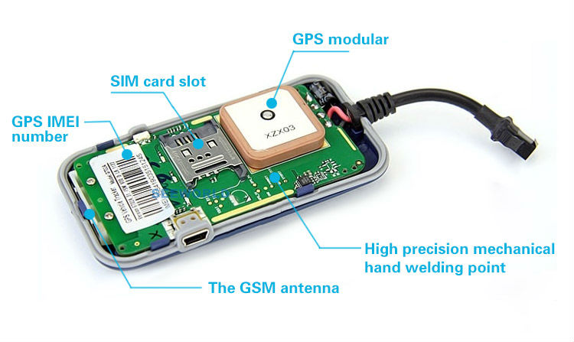

Wiring

The standard voltage is 9V-36V, the red wire is the positive, the black wire is the negative.
• Please connect the black wire to ground.

• After connecting the power cord, run the power cord plug to the device. After installation, supply power to device.

• Covert installation: car battery cord is standard; with 2A FUSE for short-circuit over current protection.

• Non covert installation: cigar lighter cord is optional, with 2A FUSE for short-circuit over current protection. Please contact your dealer if this mode is needed.

Powering on/ off

The device will power on automatically when connected to power. During normal operation, red power LED flashes, while blue GPS LED and green GSM LED keep lighting. During signal searching process, GPS or GSM LED will flash. If there is no light presenting on LEDs, the device is not working normally. please make sure the receiving side face is up, with no metal object above the device to interfere with GPS reception. The following places are suggested for installation:

The device will power off after power is disconnected.

installation place :

• Under the dash board below the front windshield;
• In the parcel shelf in the rear;
• In the front bumper( non-material face), please ensure the device cannot get wet;
• Under the wiper version (non-metal), please ensure the device cannot get wet;

Notice: If the windshield is pasted with metal thermal-protective coating, it may affect the Performance of the device. In this case, please change the installation place after consulting the professional.

Non Covert Installation: Firstly fix the device on the dash board below windshield.

Side key function

At normal-work indication status, press the side key, all the three LEDs will extinguish and then the device will enter covert working mode. Press the key again; the three LEDs will go back to normal-work indication status.

Troubleshooting :

If GPS cannot receive the signals normally, please drive to the open areas for positioning.

Generally, it needs 1-2 minutes to receive the first coordinates. If the data cannot be received after 2-3 minutes, please check the installation position of the device, making sure it is not being
Shielded by any metal.

If GSM cannot receive the signals normally, please check whether SIM card is installed correctly or there is no GSM signal at the current location, such as a basement parking, please drive to a place covered by GSM signal.

If the red LED does not work when power is connected, check whether the fuse is blown. If so, please replace the fuse.

If the three LEDs do not turn on when power up, press the down side key, if the three LEDs recover normally, the device is working normally.

If you have enabled the web based tracking application, and the device displays off-line on the platform, please check 3 LEDs status indicators first. You can check the status of the SIM card when you are in an inconvenient situation.
Please refer to the following steps:

1. Call the device to check whether you can get through.
\
2. Check whether the SIM card supports GPRS and a local APN.

3. Check the GSM/GPS reception area.

4. Check whether there is enough credit on the SIM card.

5. Check if the connector and terminal is loose or the fuse has blown out.
SMS command :

1 | Password,old password,new password# | Change password, default password:666666
1 | Example:Password,666666,777777# | Change password from 666666 to 777777
2 | Recover,new password# | Change password to default password:666666
2 | Example:recover,777777# | Change password to 666666
3 | Server,password,mode,IP/DNS,port,0# | Set server parameter.mode:0,IP mode;  mode:1, DNS Mode.
3 | Example:server,666666,0,  112.124.25.181,7018,0# | Set server IP: 121.13.112.68,server port:8821
4 | Apn,password,apn name,apn user,apn password# | Set APN
4 | Example: apn,666666,www# | Set APN name: www
5 | where,password# | position query
5 | example:where,666666# | Display Lat Lon
6 | URL,password# | Google link query
6 | example:url,666666# | Display Url
7 | timer,password,,upload time interval# | Set upload time interval.
7 | example:timer,666666,,50# | Set time zone east 2 time zones.
8 | FACTORY,password# | factory setting.IP, port,DNS  , password can not be changed
8 | actory,666666# | Change to factory setting

12

Vehicle tracking system FAQ:
• How do I use Landmarks?
They can be used to mark Boundaries, destination points, customer addresses and/or offices that you visit regularly. You can run a Landmark Report to see each time a vehicle visits a Landmark and the duration of their visit.

• What is a Landmark or Point of Interest?
Landmarks or Points of Interests are areas, addresses or locations that you want to monitor. They can be added manually, imported in bulk, changed or be exported to other formats (such as KML, used by Google Earth).

• How many Boundaries can I create?
You can create an unlimited number of Boundaries.

• What is a Boundary aka Geofence?
Boundaries are used to keep track of where a vehicle should or should not be going. After a Landmark has been created, a Boundary can be created around it. You may also choose to have the Boundary send out email notifications when broken, to any of the specified notification lists. You will have the option to create Landmarks in different forms: points, rectangles, circles, polygons and plotlines

• What types of Alerts can I receive?
SPOTER offers multiple alerts, including, but not limited to: Speeding Alerts, Boundary
Alerts, Scheduled Maintenance Alerts and Excessive Idle Alerts.

• What is an alert?
Alert is a feature to notify you via email or on the map when your vehicle(s) exceed a specified limit or threshold. For example, if you determine that your vehicles shouldn’t be driving over 75 mph, you can set up your FMS to email you a Speeding Alert when
that limit has been exceeded.

• Where does SPOTER get the mapping information?
SPOTER uses Google mapping. There are 3 different views available.
• Can I pay for my service plan monthly or annually?
You can pay monthly or annually for service. There is a 20% discount if you elect to pay annually. Our service is all-inclusive, so there is one flat fee for service based on the tracking interval you select. There is no extra charge for any basic SPOTER features or alerts.

• Will Spoter drain my car battery?
No. Although Spoter is connected to constant power it is designed to go into a very low power state when the vehicle is parked. This is compared to the same amount of power used by your car stereo.

• Can the SPOTER Fleet Management System lower my car insurance?
Yes, depending on your insurance company. Spoter is considered an Anti-Theft device. Most car insurance carriers offer policyholders a discount on their insurance premiums if cars are equipped with Anti-Theft devices. Check with your insurance company regarding discounts, typically savings are between 15-33%.

• What type of Warranty does SPOTER offer on the VAM hardware?
Customer satisfaction is important to us. We offer a 1 year standard warranty (with the purchase of an annual plan). Extended Warranties are also available.

• How long is my data archived on the SPOTER system?
Data is stored and viewable for 30 days on the Server. Fleet Managers can easily store years of historical fleet data by using our system to export to a file.

• What types of reports do I have on the SPOTER system?
We provide many customizable reports online, including: Harsh Braking, Acceleration, Speeding, Idling, Activity, Boundary, Landmarks and more.

Tracking Devices :

One of the easiest applications to consider is the simple GPS tracking device; which combines the possibility to locate itself with associated communications technologies such as radio transmission and telephony.

Tracking is useful because it enables a central tracking centre to monitor the position of several vehicles or people, in real time, without them needing to relay that information explicitly. This can include children, criminals, police and emergency vehicles, military applications, and many others.

The tracing devices themselves come in different flavors. They will always contain a GPS
receiver, and GPS software, along with some way of transmitting the resulting coordinates. GPS watches, for example, tend to use radio waves to transmit their location to a tracking center, while GPS phones use existing mobile phone technology. The tracking centre can then use that information for co-ordination or alert services. One application in the field is to allow anxious parents to locate their children by calling the tracking station - mainly for their peace of mind.

GPS vehicle tracking is also used to locate stolen cars, or provide services to the driver such as locating the nearest petrol station. Police can also benefit from using GPS tracing devices to ensure that parolees do not violate curfew, and to locate them if they do.
• What is the difference in 1 minute vs. 5 minute tracking?
Your fleet vehicles are managed in real-time. The difference is how often (every 1 minute or 5 minutes) the data will update to our server. But by using SPOTER Tracking system this duration is reduced to 9 seconds. Making Spoter an efficient and reliable Tracking system.

• What is the minimum recommended screen resolution?
The SPOTER application should be viewed at no less than 1024 x 768 screen resolution, this resolution recommended to ensure consistency.

• What operating systems and browsers are supported?
Spoter – Web based Application is completely Browser Friendly, hence it can be viewed or accessed for any Computer and a Mobile device.

• Does the SPOTER Fleet Management System offer real-time GPS tracking?
Yes, real-time tracking is available in every 9 second intervals.

• What kind of Vehicle Information can SPOTER Fleet Management Software provide?
Vehicle Information provides important Device Alerts, such as: Maintenance Alerts, Daily Heartbeat, GPS Blocked, GPS Tamper, GSM Jamming and Vehicle Battery Voltage Alerts.

• What kind of Driver Behavior Information can the SPOTER Fleet Management System provide?
The Driver Behavior section provides Acceleration Alerts, Harsh Braking, Harsh Cornering, Excessive Speeding, Boundary and Idle Alerts.

• Can I use my GPS enabled cell phone to track my vehicles?
SPOTER is permanently installed to constant power in your fleet vehicle, whereas a cell phone may need its battery charged on a daily basis...
Management GPS tracking device with the intelligence of web-based mapping...

Tracking Devices :

One of the easiest applications to consider is the simple GPS tracking device; which combines the possibility to locate itself with associated communications technologies such as radio transmission and telephony.

Tracking is useful because it enables a central tracking centre to monitor the position of several vehicles or people, in real time, without them needing to relay that information explicitly. This can include children, criminals, police and emergency vehicles, military applications, and many others.

The tracing devices themselves come in different flavors. They will always contain a GPS
receiver, and GPS software, along with some way of transmitting the resulting coordinates. GPS watches, for example, tend to use radio waves to transmit their location to a tracking center, while GPS phones use existing mobile phone technology. The tracking centre can then use that information for co-ordination or alert services. One application in the field is to allow anxious parents to locate their children by calling the tracking station - mainly for their peace of mind.

GPS vehicle tracking is also used to locate stolen cars, or provide services to the driver such as locating the nearest petrol station. Police can also benefit from using GPS tracing devices to ensure that parolees do not violate curfew, and to locate them if they do.

SEETINGS FOR M2100 MODELS

FACTORY PASSWORD: 666666 1ST YR. SERVER: SERVER2
SMS ENQUIRY: where,666666# / url,666666#

Sl | Description | format | On currect result
1. | Factory settings | factory,666666# | OK
2. | India time zone set | gmt ,666666,E,5,30# | OK
3. | Vodaphone APN set | apn,666666,www# | OK
4. | Time interval set 30Seconds. | timer,666666,30# | OK
5. | SERVER2 settings | server,666666,0,118.193.48.237,7018,0# | OK
6. | SERVER1 settings | server,666666,0,23.226.141.151,5002,0# | OK
7. | Location track by sms normal | where,666666# | LAT: XXXX XXX  LON: XXXX XXX
8. | URL track by sms normal | url,666666# | URL: XXXX XXX  SPEED: XXXX
9. | CHANGE password to 777777 | password,666666,777777# | OK
10. | RECOVER password | recover,777777# | OK
11. | REBOOT device | Reset,666666# | OK
12. | Software Version Check | version,666666# | VERSION
13. | Parameter settings Check | param,666666# | PARAM IMEI TIME
14. | Simplify Parameter settings | scxsz,666666# | SYS LIVESERVER
15. | GPRS Parameter settings | gprsset,666666# | GPRS SETINGS
16. | STATUS check | status,666666# | SYS STATUS

ERROR ID FOR M2100 MODELSTHROUGH SMS

Sl | Error ID | Error Description
1. | 100 Extend | Ruled length Error
2. | 101 Data | Data Ruled length Error
3. | 102 wrong | Command format Error
4. | 103 wrong | password format Error
 | 104 | SOS no. exceed the range Error
 | 105 | SOS NO. is NULL Error
 | 106 | Serial no and Detected SOS No Error
 | 107 | Command string Error
 | 108 | No technical bit, plz end with # Error
 | 109 Wrong | password Error

• What is GPS and how does it work?
GPS (Global Positioning System) is comprised of 30 satellites called NAVSTARs orbiting the earth. The presence of at least 3 satellites is required...

• Why should I choose SPOTER Fleet over other GPS tracking solutions?
Unlike most GPS tracking companies, SPOTER Fleet is the manufacturer of its GPS tracking hardware as well as a provider of a web-based fleet management solution...

• What is SPOTER's Fleet Management System (FMS)?
SPOTER Fleet Management System combines our state of the art Vehicle Asset Management GPS tracking device with the intelligence of web-based mapping...

13

Purchase Order:

14

DEMO BILL & STAMP:

One of the easiest applications to consider is the simple GPS tracking device; which combines the possibility to locate itself with associated communications technologies such as radio transmission and telephony.

Tracking is useful because it enables a central tracking centre to monitor the position of several vehicles or people, in real time, without them needing to relay that information explicitly. This can include children, criminals, police and emergency vehicles, military applications, and many others.

The tracing devices themselves come in different flavors. They will always contain a GPS
receiver, and GPS software, along with some way of transmitting the resulting coordinates. GPS watches, for example, tend to use radio waves to transmit their location to a tracking center, while GPS phones use existing mobile phone technology. The tracking centre can then use that information for co-ordination or alert services. One application in the field is to allow anxious parents to locate their children by calling the tracking station - mainly for their peace of mind.

GPS vehicle tracking is also used to locate stolen cars, or provide services to the driver such as locating the nearest petrol station. Police can also benefit from using GPS tracing devices to ensure that parolees do not violate curfew, and to locate them if they do.
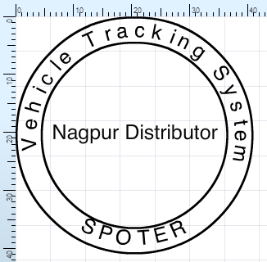

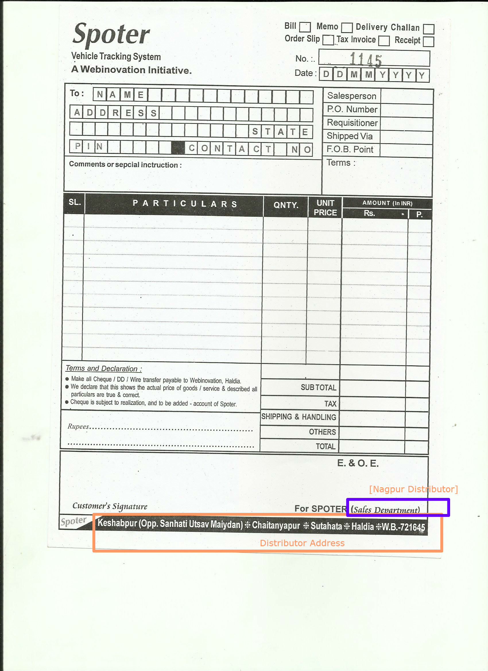

15

Device On Rental :

One of the easiest applications to consider is the simple GPS tracking device; which combines the possibility to locate itself with associated communications technologies such as radio transmission and telephony.

Tracking is useful because it enables a central tracking centre to monitor the position of several vehicles or people, in real time, without them needing to relay that information explicitly. This can include children, criminals, police and emergency vehicles, military applications, and many others.

The tracing devices themselves come in different flavors. They will always contain a GPS
receiver, and GPS software, along with some way of transmitting the resulting coordinates. GPS watches, for example, tend to use radio waves to transmit their location to a tracking center, while GPS phones use existing mobile phone technology. The tracking centre can then use that information for co-ordination or alert services. One application in the field is to allow anxious parents to locate their children by calling the tracking station - mainly for their peace of mind.

GPS vehicle tracking is also used to locate stolen cars, or provide services to the driver such as locating the nearest petrol station. Police can also benefit from using GPS tracing devices to ensure that parolees do not violate curfew, and to locate them if they do.

16

Best Scecure Place :

One of the easiest applications to consider is the simple GPS tracking device; which combines the possibility to locate itself with associated communications technologies such as radio transmission and telephony.

Tracking is useful because it enables a central tracking centre to monitor the position of several vehicles or people, in real time, without them needing to relay that information explicitly. This can include children, criminals, police and emergency vehicles, military applications, and many others.

The tracing devices themselves come in different flavors. They will always contain a GPS
receiver, and GPS software, along with some way of transmitting the resulting coordinates. GPS watches, for example, tend to use radio waves to transmit their location to a tracking center, while GPS phones use existing mobile phone technology. The tracking centre can then use that information for co-ordination or alert services. One application in the field is to allow anxious parents to locate their children by calling the tracking station - mainly for their peace of mind.

GPS vehicle tracking is also used to locate stolen cars, or provide services to the driver such as locating the nearest petrol station. Police can also benefit from using GPS tracing devices to ensure that parolees do not violate curfew, and to locate them if they do.

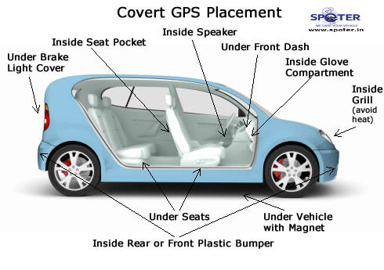

One of the easiest applications to consider is the simple GPS tracking device; which combines the possibility to locate itself with associated communications technologies such as radio transmission and telephony.

Tracking is useful because it enables a central tracking centre to monitor the position of several vehicles or people, in real time, without them needing to relay that information explicitly. This can include children, criminals, police and emergency vehicles, military applications, and many others.

The tracing devices themselves come in different flavors. They will always contain a GPS
receiver, and GPS software, along with some way of transmitting the resulting coordinates. GPS watches, for example, tend to use radio waves to transmit their location to a tracking center, while GPS phones use existing mobile phone technology. The tracking centre can then use that information for co-ordination or alert services. One application in the field is to allow anxious parents to locate their children by calling the tracking station - mainly for their peace of mind.

GPS vehicle tracking is also used to locate stolen cars, or provide services to the driver such as locating the nearest petrol station. Police can also benefit from using GPS tracing devices to ensure that parolees do not violate curfew, and to locate them if they do.

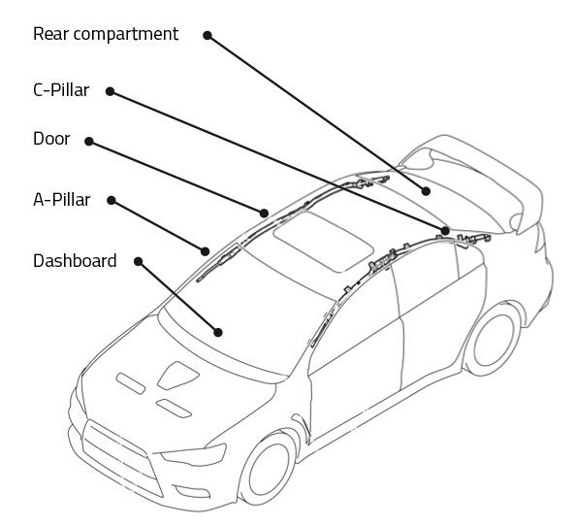

17

Product Comparison:

Product Comparison
Sl No | Terms | ABC Co. | XYZ Co. | Spoter
1 | Tracking Map | Tracking on normal open street Map | Tracking on highly detailed maps on India’s  Digital Map | Tracking on highly detailed maps on Google , Openstreet, Baidu’s Map
2 | Track your vehicle using your Smartphone | Track your vehicle using your Smartphone without Latest -Smart Apps | Track your vehicle using your Smartphone with Latest -Smart Apps | Track your vehicle using your Smartphone with Latest -Smart Apps
3 | Waterproof Device | Waterproof Device | Waterproof Device | Waterproof Device
4 | Body of Device | Normal plastics | soft fiber | soft fiber with gloss lamination
5 | Internal Antennae | Normal Internal Antennae | Internal Antennae in build with basic technology | Electro-magnetic Internal Antennae, have 3 IC for control it, 1for satellite signal, 1 for GSM signal, 1 for GSM LOCATE Optional where Satellite signal not available.
6 | Types of Tracking Satellites | china Regional Navigation Satellite System | Indian Regional Navigation Satellite System | 27pcs USA based and international Satellites , The signal change over automatically satellite to satellite depend on place
7 | Playback | 7 days playback History | 7 days playback History | 30 days playback History
8 | reports | 1month | 1month | 3month
9 | Streaming technology | Not supported | Not supported | Supported
10 | GSM Technology | Provide Airtel SIM | Provide Airtel SIM | Support Any SIM and convert in to panel
11 | Special Online Service Station-Panel Access | Not available | Not available | Work in process available shortly in distributor lavel
12 | Data Upload interval | 30 sec. | 30 sec. | 10 Sec. with Streaming technology, 15 Sec. without Streaming technology
13 | Uploaded Data Session | 30 sec. interval data | 30 sec. interval data | 1-3 Sec interval data
14 | SMS function | Manual, limit 100 SMS/Month | Manual, limit 100 SMS/Month | Manual, limit 100 SMS/Month
15 | Auto Email | manual | Automatic | Manual currently, Work in process to upgrade automatically available shortly
16 | Geo Francs | Supported | Supported | Supported

Product Comparison
Sl No | Terms | ABC Co. | XYZ Co. | Spoter
11 | Special Online Service Station-Panel Access | Not available | Not available | Work in process available shortly in distributor level
12 | Data Upload interval | 30 sec. | 30 sec. | 10 Sec. with Streaming technology, 15 Sec. without Streaming technology
13 | Uploaded Data Session | 30 sec. interval data | 30 sec. interval data | 1-3 Sec interval data
14 | SMS function | Manual, limit 100 SMS/Month | Manual, limit 100 SMS/Month | Manual, limit 100 SMS/Month
15 | Auto Email | manual | Automatic | Manual currently, Work in process to upgrade automatically available shortly
16 | Geo Francs | Supported | Supported | Supported
17 | Real time tracking | Supported | Supported | Supported
18 | Server | Own 1 GPS Tracking Server | Own 1 GPS Tracking Server | Currently 4 GPS Tracking Server, 1 Own GPS Tracking Server, tie-ups with 3 Server, Work in process to launch a super server, available shortly
19 | History Downloadable in Google earth / KML Format | Non-Supported | Supported | Supported
20 | SMS Based Tracking | Supported | Supported | Supported
21 | Data Volume | 40 MB | 40MB | Near About 1GB with Streaming Technology
22 | 2G/3G GSM SIM | Supported | Supported | Supported
23 | Alert | MAX 12 types of Alert | MAX 15 types of Alert | MAX 26 types of Alert
24 | Reports | MAX 6 types of Alert | MAX 15 types of Alert | MAX 26 types of Alert
25 | Antitheft | Supported | Supported | Supported
26 | 2 way voice communication | Supported | Non-Supported in basic model | Non-Supported in basic model, available shortly
27 | Over speed Alert | Supported | Supported | Supported
28 | Internal Battery Backup | Not available in basic model | available | Not available in basic model, available shortly
29 | Destination facing | Supported | Supported | Supported
30 | Distributor Network | Available in cities | Online only | In Progress to build up distributor network in every district in India
31 | Operative area | All India | All India | All India
32 | Price in Kolkata | 8400/*-+ | 9999/*- without Installation | 9999/*- with Installation

Product Comparison
Sl No | Terms | ABC Co. | XYZ Co. | Spoter
28 | Internal Battery Backup | Not available in basic model | available | Not available in basic model, available shortly
29 | Destination facing | Supported | Supported | Supported
30 | Distributor Network | Available in cities | Online only | In Progress to build up distributor network in every district in India
31 | Operative area | All India | All India | All India
32 | Price in Kolkata | 8400/*-+ | 9999/*- without Installation | 9999/*- with Installation
33 | up gradation sms and data packs | Not available | Not available | Supported
34 | Distributor Commission | 450/-* | Not Applicable | 3000/-*+
35 | National e-marketing Advertising Campaign | Not available | Supported | Now campaign running for sourcing distributor network, customer sourcing campaign will be started shortly
36. | Distributor Website | Not available | Not available | Available
37. | warrantee | 1yr. repairable | 1yr. repairable | 1yr. replacement
38. | Production center | china | India | Currently Hardwar import from China, Assembled and packaged in India, Very soon Our production Center will start in INDIA.
39 | International Tie-Up | China + India | India, Own R&D and Production Center | India+China+USA+Srilanka  Way to setup Own International Class R&D and production Center completed within Dec’15
40 | Server | VPS | VPS | VPS, Way to setup Own Data Center in INDIA completed within Dec’15
41 | Data Acquisitioned | N/A | Smart Data Acquisitioned | Smart Data Acquisition without Streaming Technology, New Exclusive Streaming Technology supported device available.
43. | Installation Service | Available with installation Charge | Non- Available | Available, installation Charge include in price.
44. | Support /Service Center | Available from Head Quarter | Available from Head Quarter | Available from Head Quarter and online based will available at all distributor point.
45 | Mark 'Areas' and color coded 'Places' | Available some cases | available | Available as on google map mark-up
46 | Weather forecast | Non-available | Non-available | Available
47 | Traffic Update | Non-available | Non-available | As google network

Product Comparison
Sl No | Terms | ABC Co. | XYZ Co. | Spoter
44. | Support /Service Center | Available from Head Quarter | Available from Head Quarter | Available from Head Quarter and online based will available at all distributor point.
45 | Mark 'Areas' and color coded 'Places' | Available some cases | available | Available as on google map mark-up
46 | Weather forecast | Non-available | Non-available | Available
47 | Traffic Update | Non-available | Non-available | As google network

18

Installation Technique:

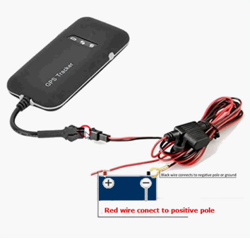

19

Employee Management

System SETUP :
Go to our website www.spoter.in
AND DOWNOAD THE APPS

- CLICK HERE
DOWNOAD THE APPS

- CLICK HERE

INSTALL THE APPS

- CLICK HERE

- CLICK HERE
Go to Your Menu and Open
SPOTER SERVERS ICON.

- CLICK HERE

CLICK ON : SPOTER MCLIENT

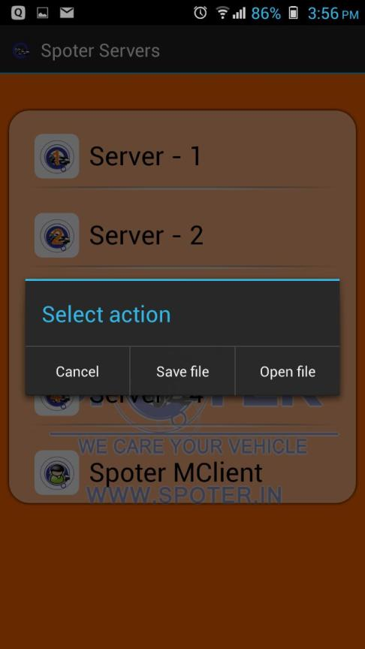

- CLICK HERE
SAVE THE FILE AND
Go to your FILE EXPLORAR

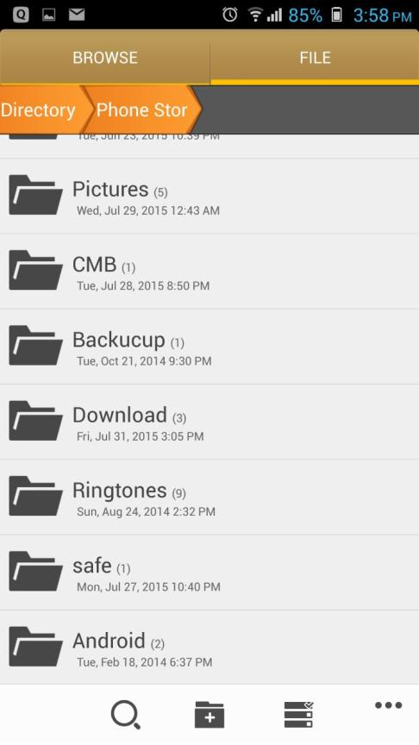
- CLICK
HERE
CLICK TO : OPEN DOWNOAD FOLDER

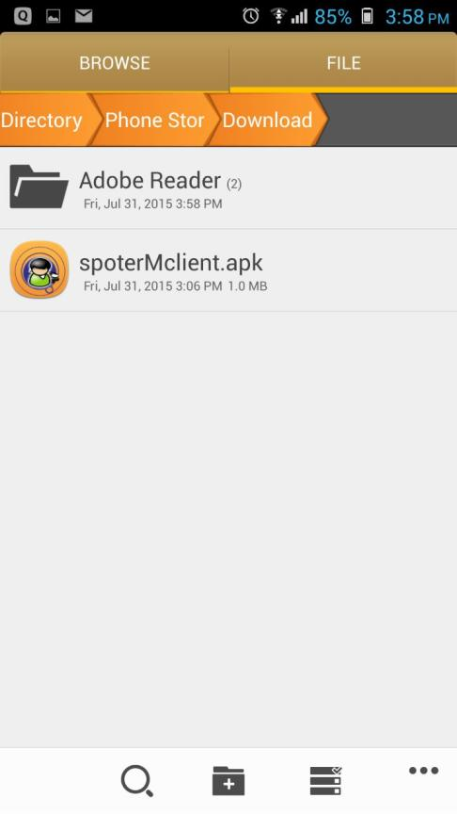
CLICK Spoter Mclient .apk FOR INSTALLATION

- CLICK HERE

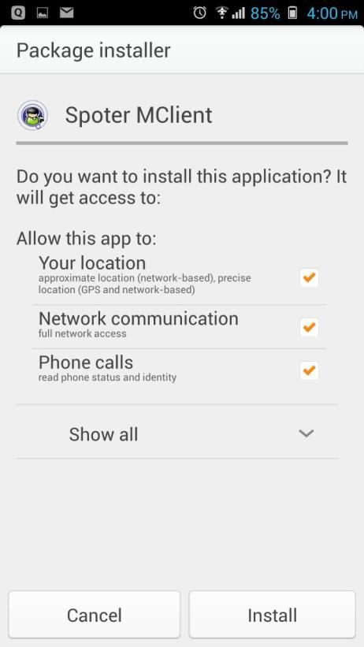
- CLICK HERE

CLICK INSTALL

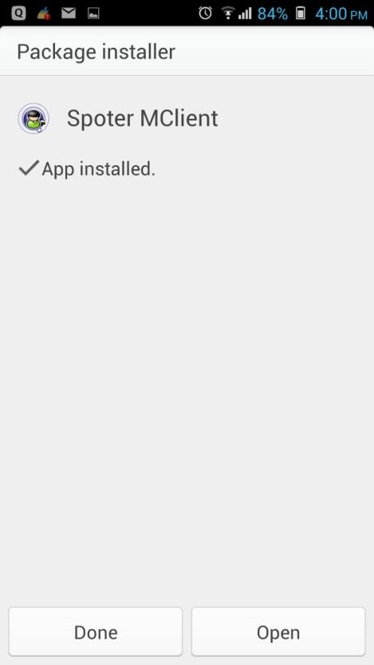
CLICK DONE
[ INSTALLATION COMPLITED ]

- CLICK HERE
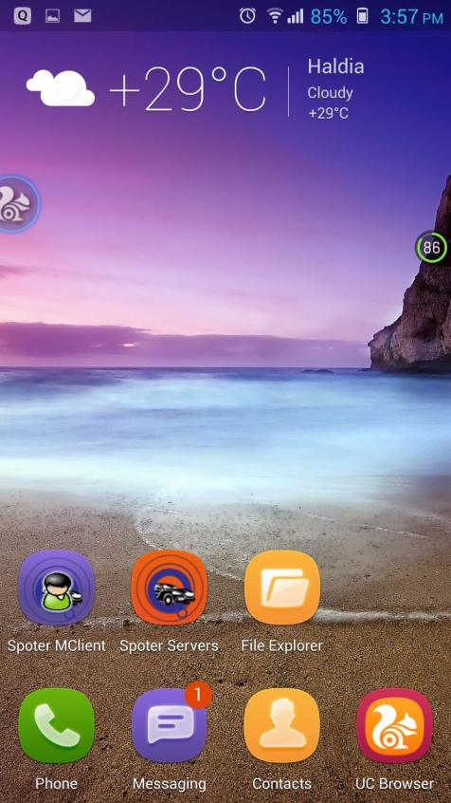
- CLICK HERE

Go to your MENU
AND CLICK SPOTER MCLIENT ICON

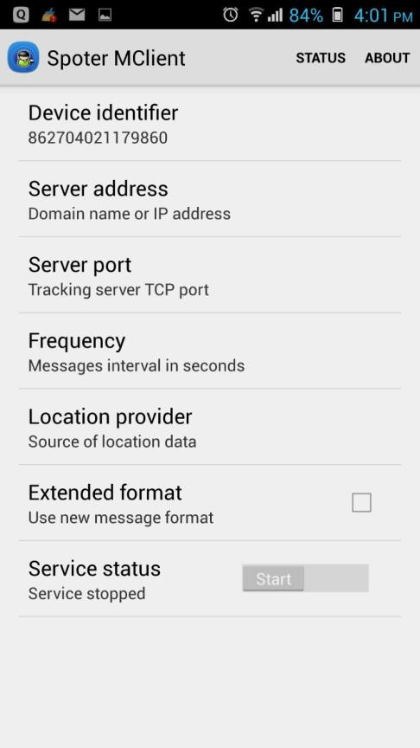
CLICK START
For start the services

- CLICK HERE
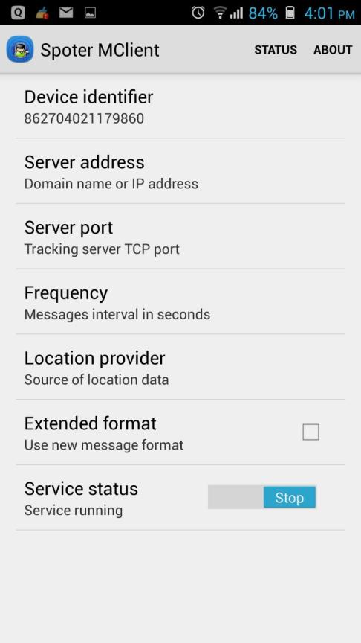
- CLICK HERE

CLICK LOCATION PROVIDER
[ For start Location services ]

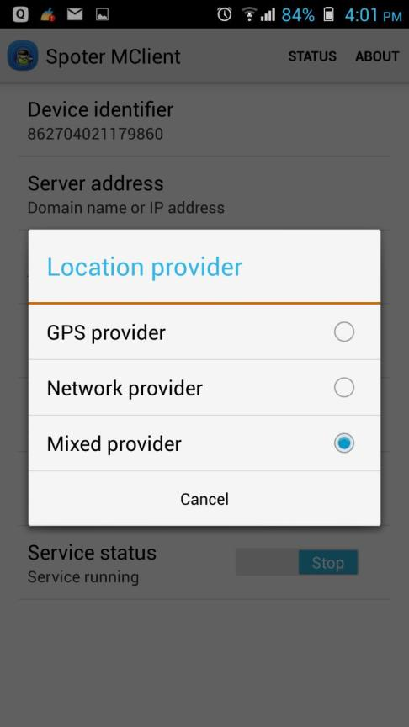
SELECT MIXED PROVIDER
AND CLOSE THE SOFTWAR
GO MOBILE MAIN MANU

- CLICK HERE

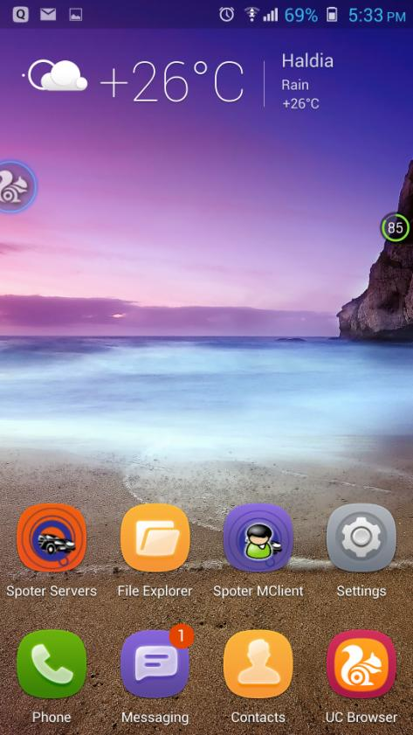
- CLICK HERE

CLICK SETTINGS ICON

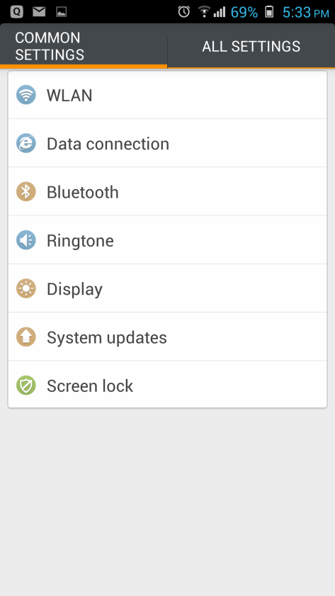
- CLICK HERE

SELECT ALL SETTINGS

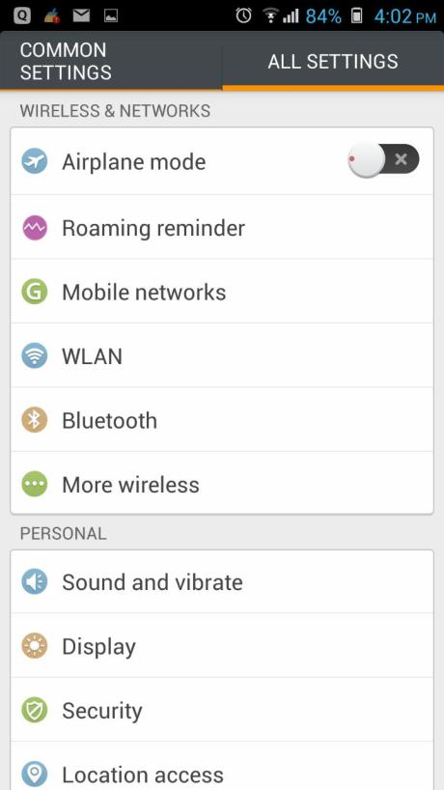
- CLICK HERE

SELECT LOCATION ACCESS

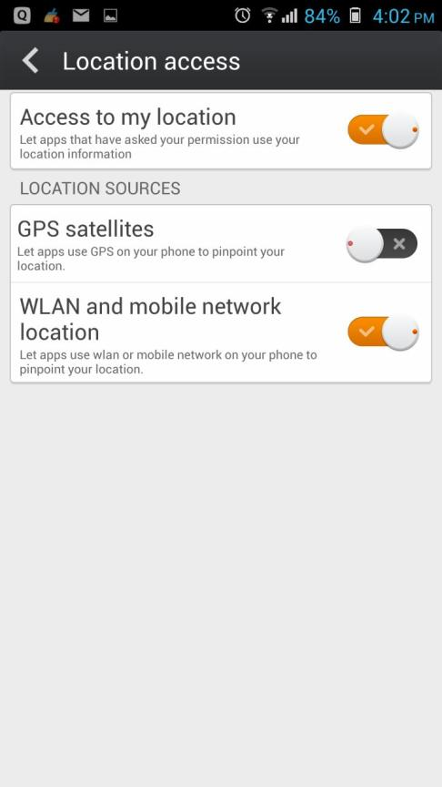
ON Access to my Location

- CLICK HERE
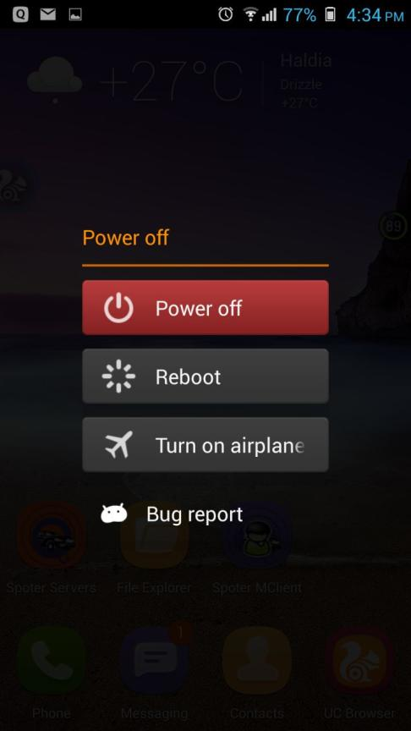

CLICK REBOOT / RESTART
[ For Restart the Mobile ]

- CLICK HERE

CLICK SpoterMClient
[ Open The apps ]

- CLICK HERE

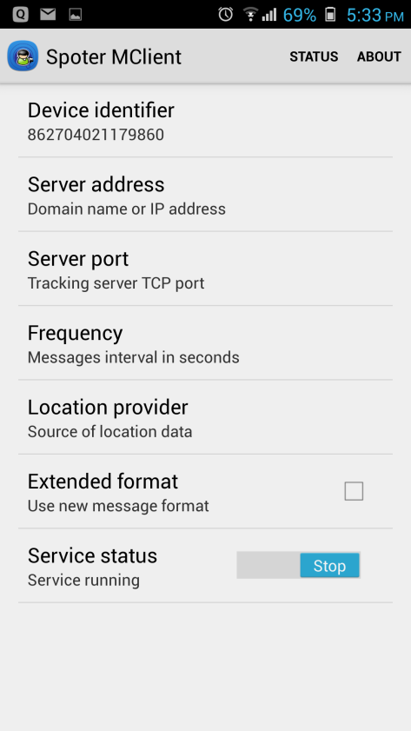

Check the service Status

Note : This Device identifier ID No.
[ This is Unique id ]
Inform Spoter Team for Activate Service

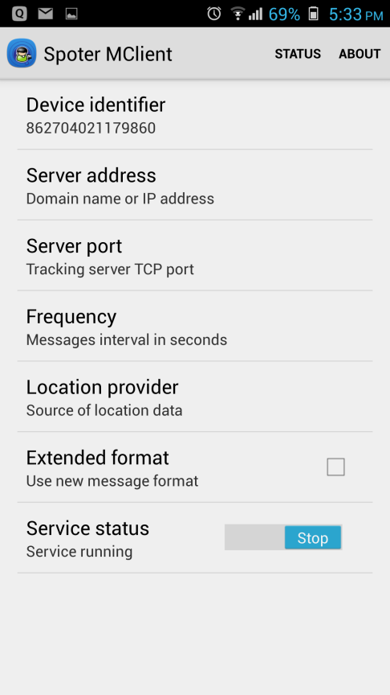

CLICK STATUS
- CLICK HERE

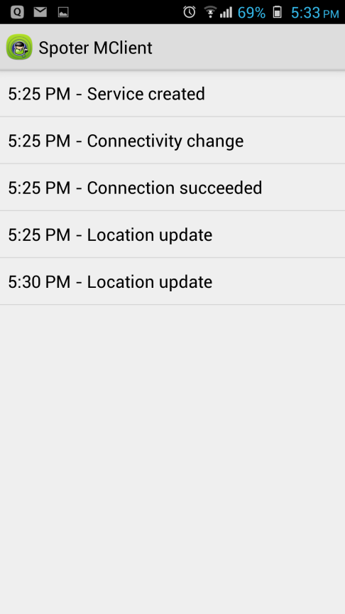
NOW YOUR INSTALLATION IS COMPLITED
CONTACT SPOTER FOR USER ID & PASSWORD
FOR ONLINE TRACKING

Check It Give Location Update

HOW TO CHECK APPLICATION VERSION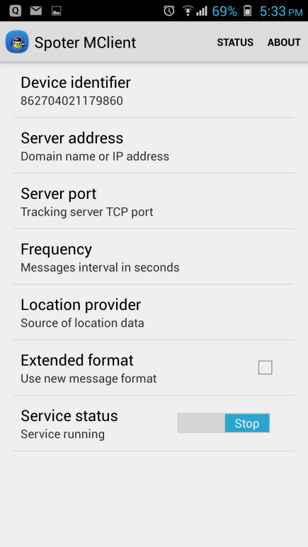

CLICK ABOUT for view
Apps Details.

CLICK HERE
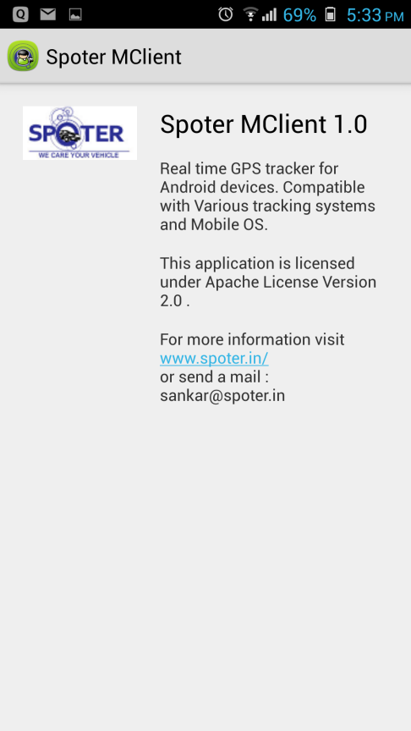

Application
Version

20

Get Support :

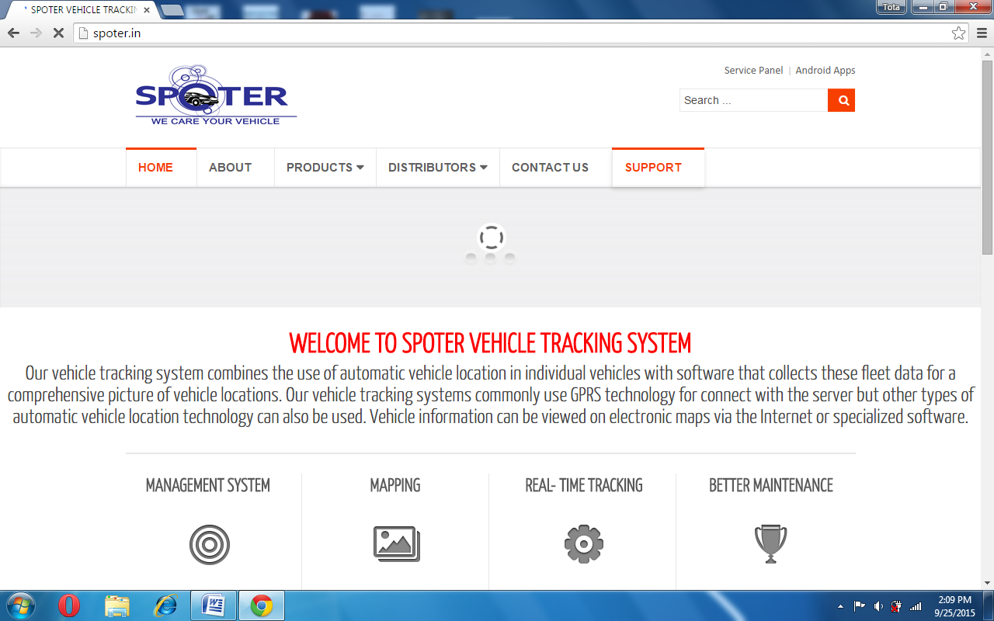

- Click HERE

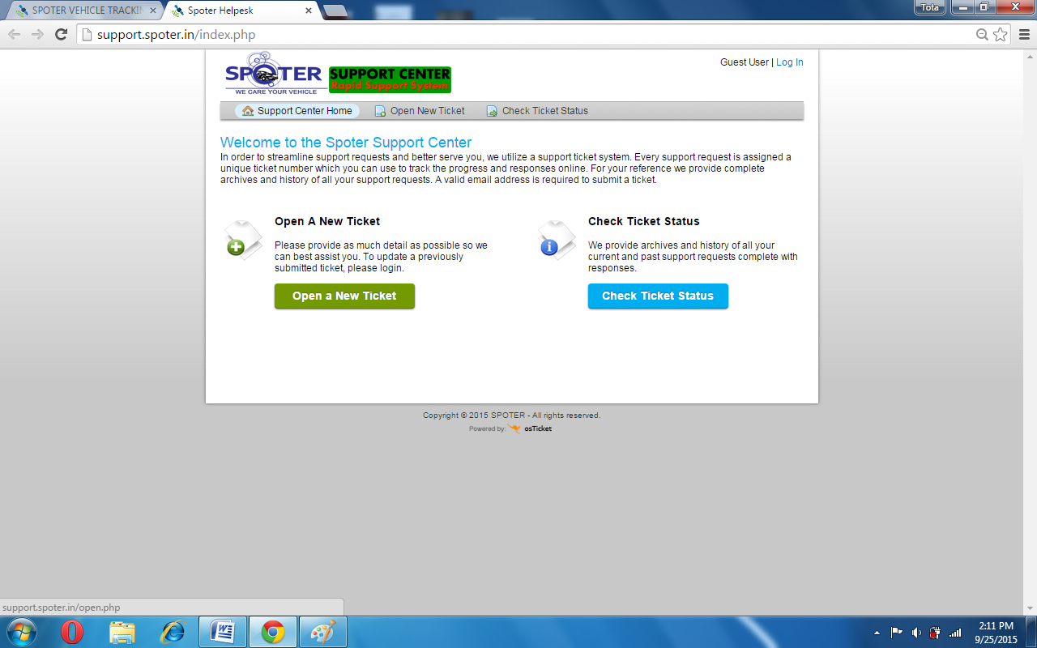

- Click HERE

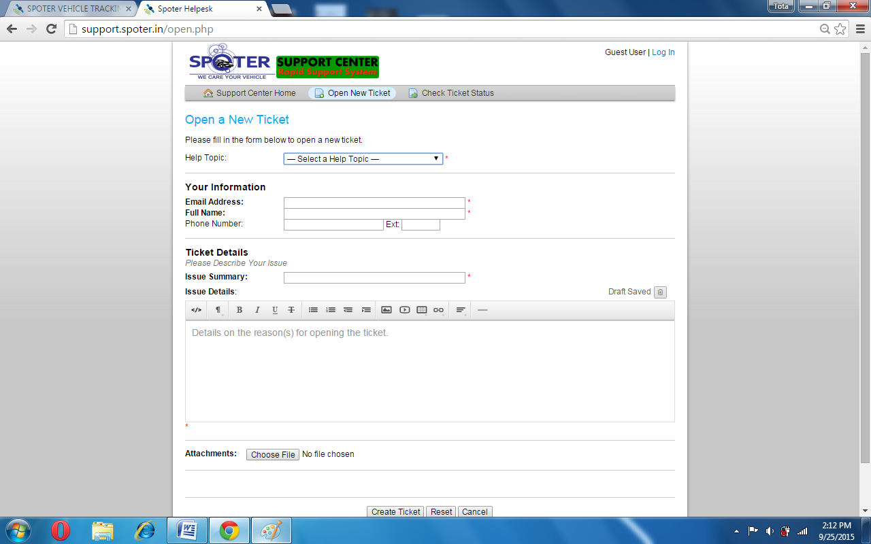

- Fill Up the
From
AND
Submit
Your Support
Ticket created

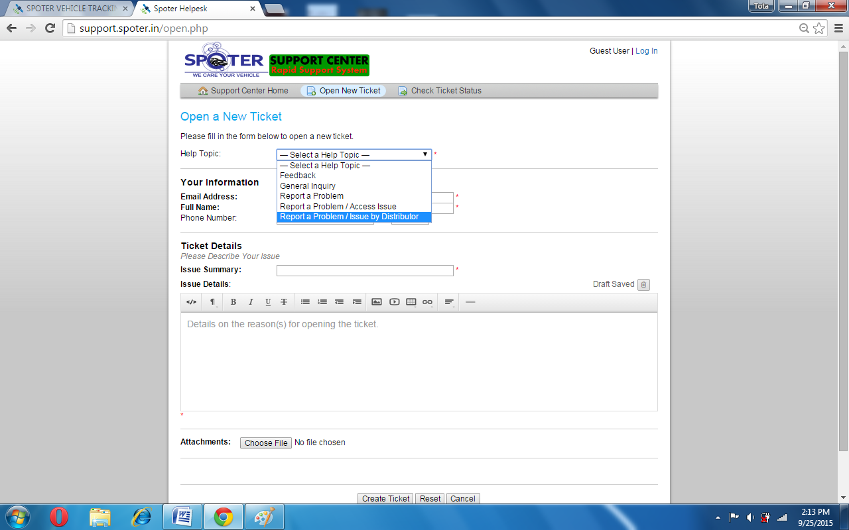

- Special Helpdesk Support For
DISTRIBUTOR &
FRANCHISEE

- Special Helpdesk Support For
DISTRIBUTOR &
FRANCHISEE

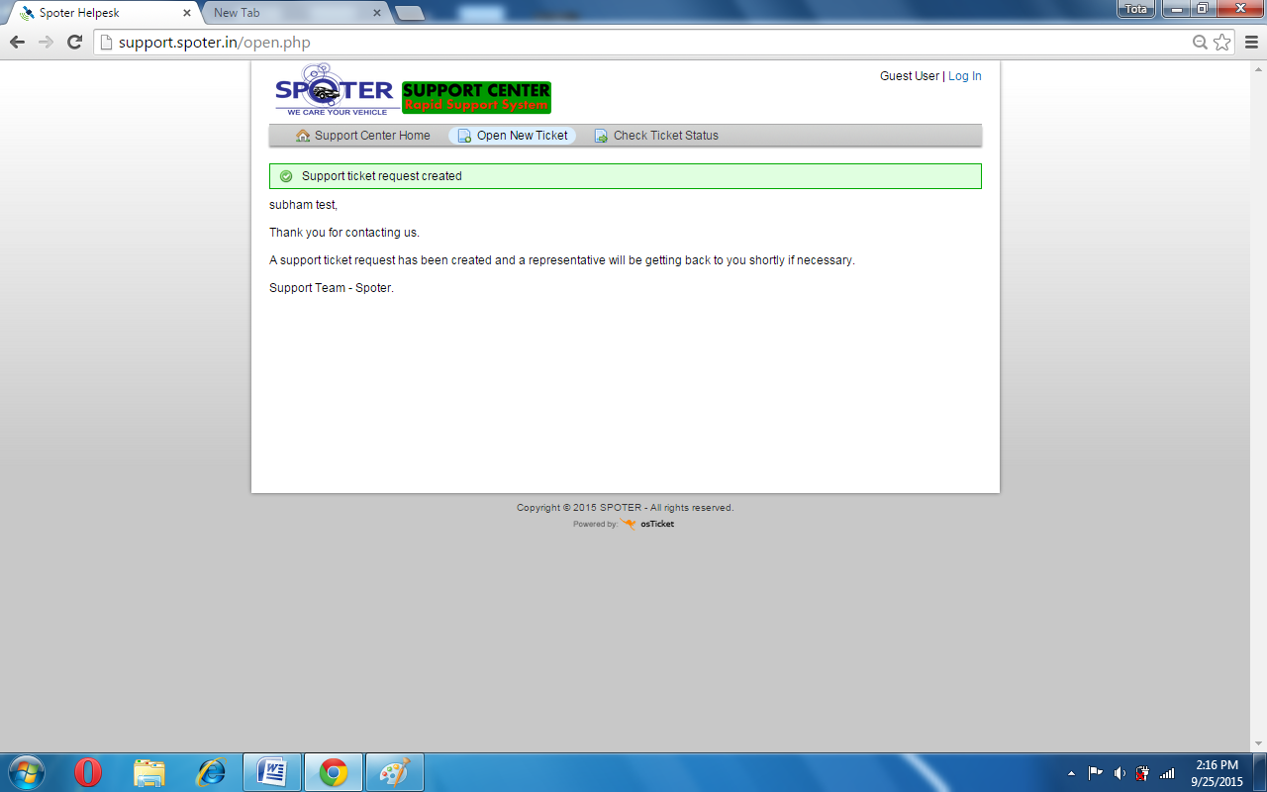

- Your support ticket is created. You will get response as soon as possible.

Tracking Devices :

One of the easiest applications to consider is the simple GPS tracking device; which combines the possibility to locate itself with associated communications technologies such as radio transmission and telephony.

Tracking is useful because it enables a central tracking centre to monitor the position of several vehicles or people, in real time, without them needing to relay that information explicitly. This can include children, criminals, police and emergency vehicles, military applications, and many others.

The tracing devices themselves come in different flavors. They will always contain a GPS
receiver, and GPS software, along with some way of transmitting the resulting coordinates. GPS watches, for example, tend to use radio waves to transmit their location to a tracking center, while GPS phones use existing mobile phone technology. The tracking centre can then use that information for co-ordination or alert services. One application in the field is to allow anxious parents to locate their children by calling the tracking station - mainly for their peace of mind.

GPS vehicle tracking is also used to locate stolen cars, or provide services to the driver such as locating the nearest petrol station. Police can also benefit from using GPS tracing devices to ensure that parolees do not violate curfew, and to locate them if they do.

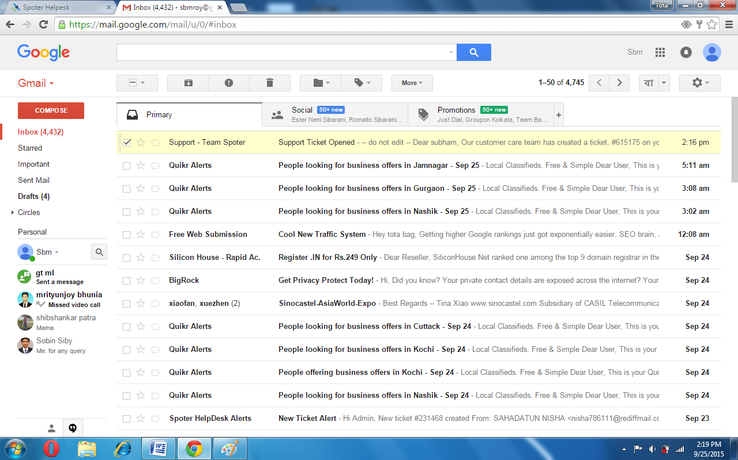

- A Mail also send to you at per Response

- Support Ticket ID

- You Can Get direct Access your Support
Ticket.
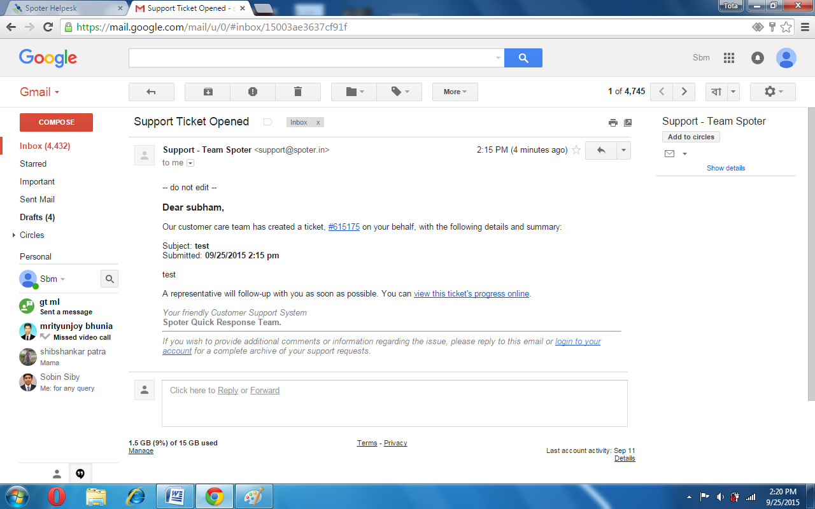

- Your
Response Details

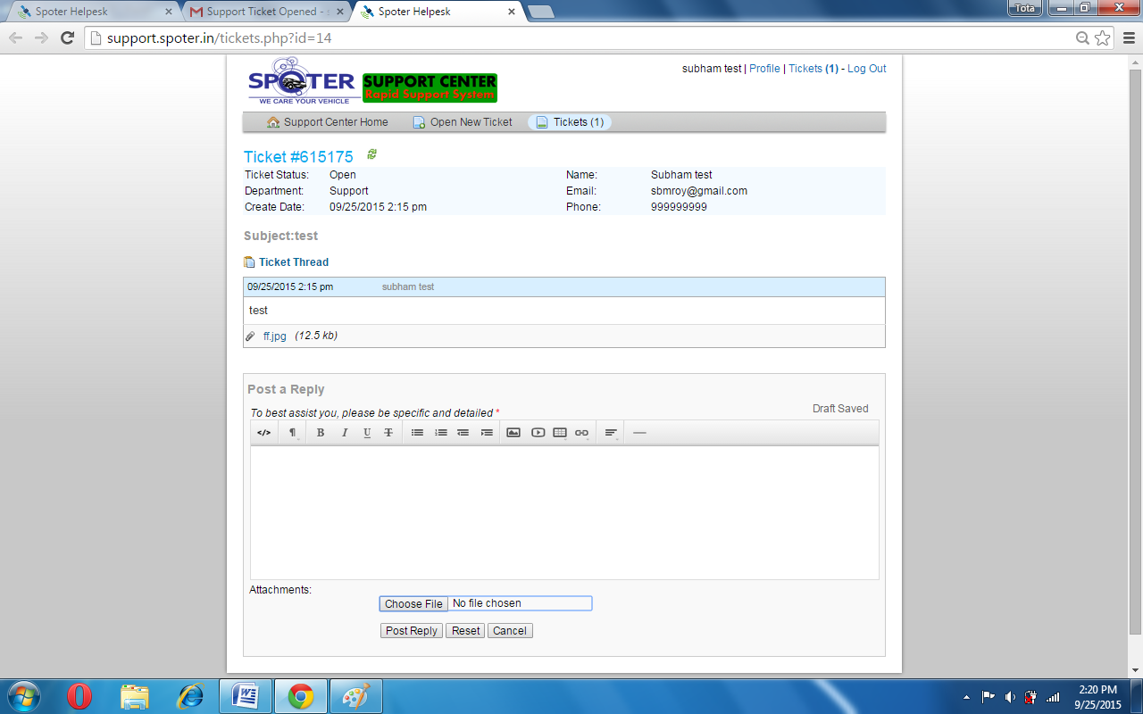

You can Directly Mail to Support@spoter.in

A Support Ticket will be generated automatically.

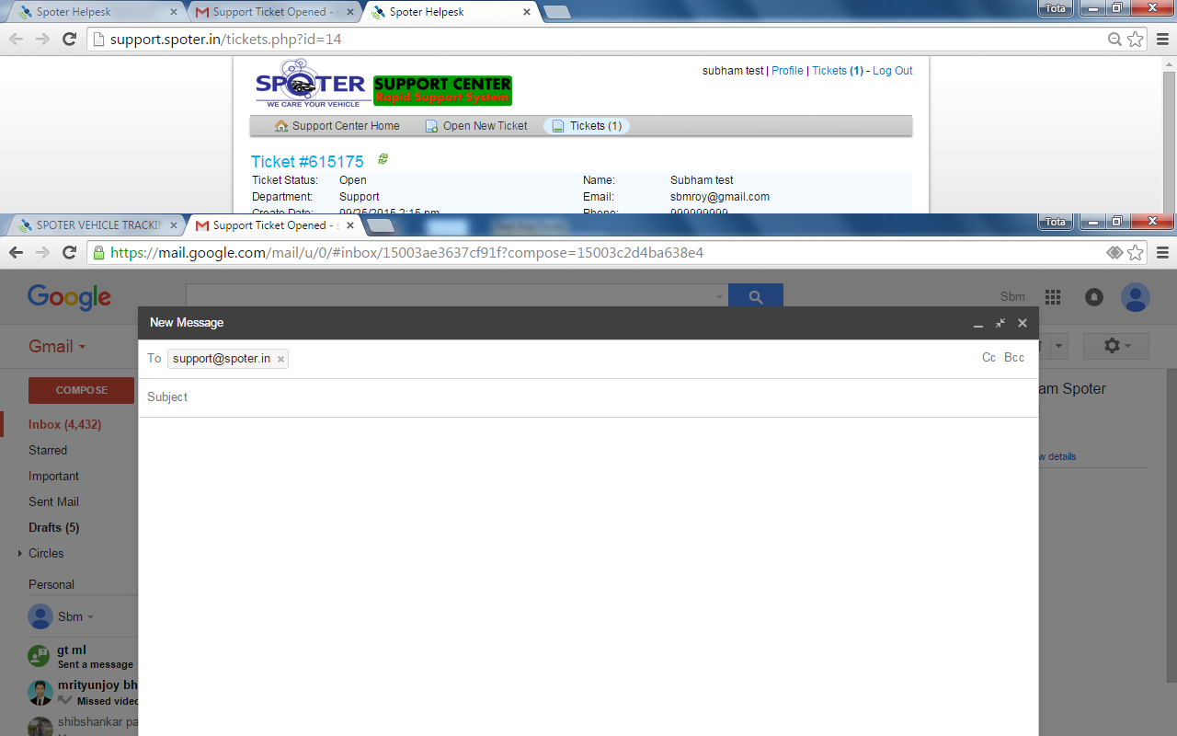

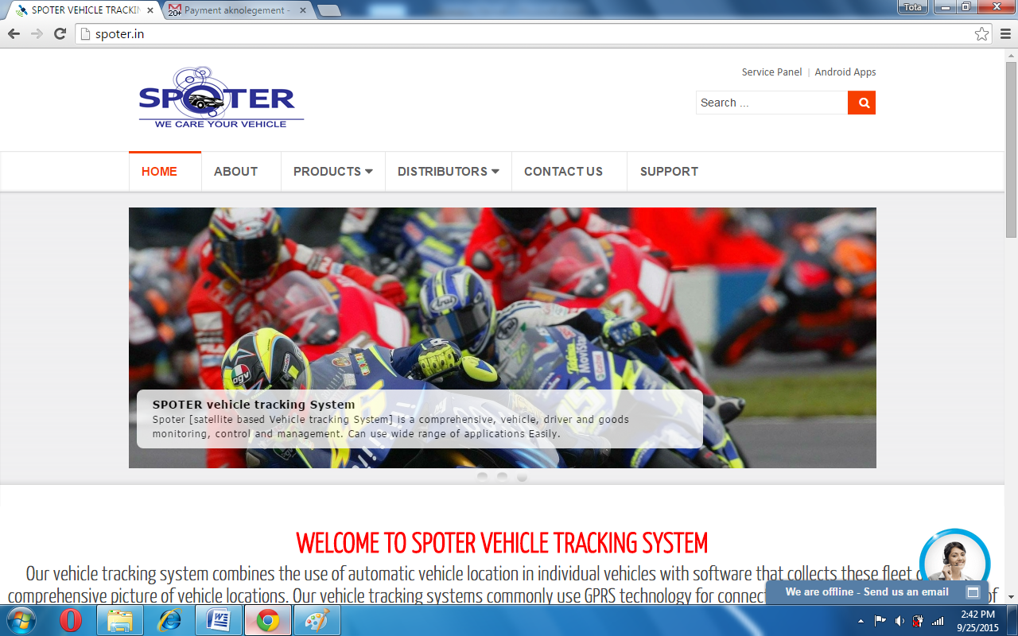

You can directly get live Support from here.

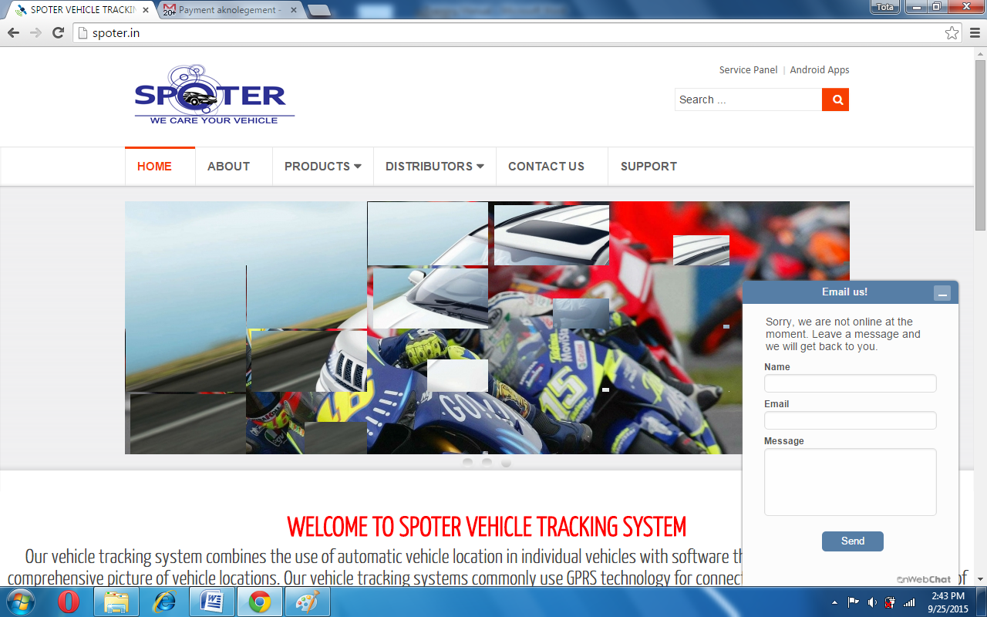

You can sent a support request from here

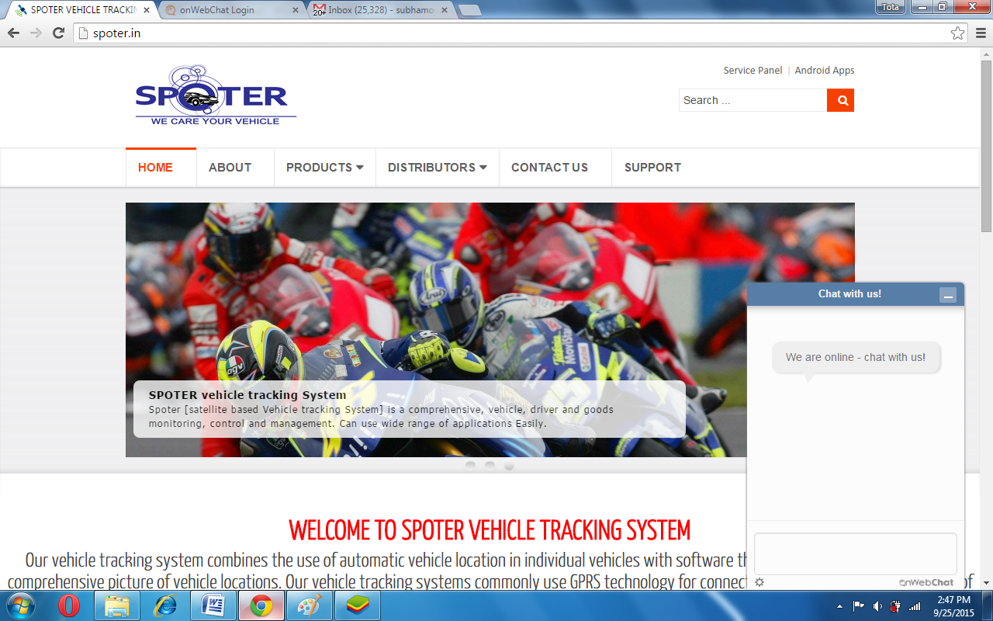

You can directly get support Live Helpdesk from here.



We wish you a fruitful business and all
success in your Area of Operation.

